JULY UPDATE

BALLSTONE, BALLINGHAM & HENTLAND, DINEDOR, HOLME LACY, LITTLE DEWCHURCH and LOWER BULLINGHAM
DINEDOR HILL WARD

From your local County Councillor

David Davies

david.davies2@herefordshire.gov.uk
Dear Residents

The recent heatwave was certainly a challenge for us all and we need to improve our preparation and ability to cope with high temperatures better. Closing curtains on windows facing the sun helps keep rooms cooler and more bearable. Using fans to help move air and keep us cool also helps.

Following the ongoing roadworks in Holme Lacy Road, with the remodelling of the junctions and narrowing of the roads in some parts, I have received many emails expressing concerns. I have been in contact with the highways team expressing the concerns raised. Whilst these plans were put in place years ago, the reality can sometimes cause us to question the decisions made then. However, I am sure once the work is complete and the kerbs, pavements and road surface established with the necessary road linings it will be an acceptable upgrade.
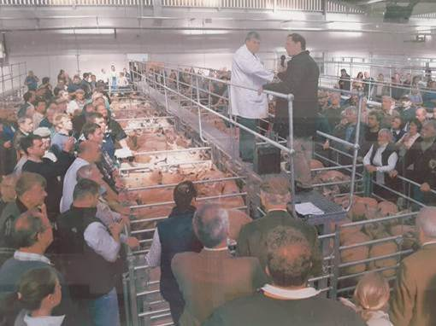
Its 15 years since the new Livestock market the council had built on the Roman Road at Credenhill opened. It was an important decision when the Council moved the market out of the centre and release the old site for commercial development. There was lots of opposition at the time, as usual in Hereford, but the result I believe was a great improvement with the new market now recognised as one of the busiest in England and Wales being expanded by the auctioneers.
Photo : Official opening on 23rd June 2011.

The old site supported new retail into the city and I think has helped Hereford in these challenging times with new modern shops, restaurants, multiplex cinema and Waitrose.

The livestock market brings in over 400K per year to the council`s revenue account and the increase in business rates on the old site over a million pounds extra together with increased parking income from Garrick multi-storey.

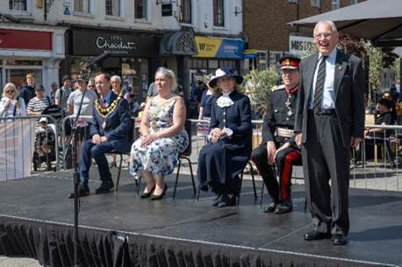
At the end of June we celebrate Armed Forces week across the nation. It is an opportunity to acknowledge the importance of defending our country and the freedoms we so take for granted. Herefordshire has a long military tradition which in recent generations has strengthened to being our largest single employer with an estimated 1,000 military children in our county primary and secondary schools.
183 businesses and public bodies in the county have signed up to the Armed Forces Covenant which helps support the large number of veterans who transfer from military to civilian life. The council is very supportive and supports a Veterans centre which with many voluntary organisations gives support, advice and friendship to ex- military.
Photo - the platform for the raising of the flag in Hightown Hereford with Lord Lieutenant, High Sheriff, Hereford Mayor and Chairman Herefordshire Council. There was also a special day hosted at Lady Hawkins School where some of the pupils gave excellent speeches.

In 2009 also when we built a new crematorium in Hereford. Higher environmental standards and larger population meant that we had to build a new facility.

The Council are having an open morning on the 4th July when you can visit. The event provides an opportunity to learn more about the facilities, the service provided, and the care taken in supporting families during difficult times.

You will be able to talk to representatives of different organisations who can offer guidance on registering a death, planning a funeral, cremations, burials and bereavement support. Visitors will be able if they want to take an information tour of the premises.


In this month’s update I cover the publication of our local Fire service annual report, the latest on Highways plus usual contact lists.

As ever if I can be of any help, please don’t hesitate to contact me.

Stay safe and well

Dave

Fire Service Report for 2025/26
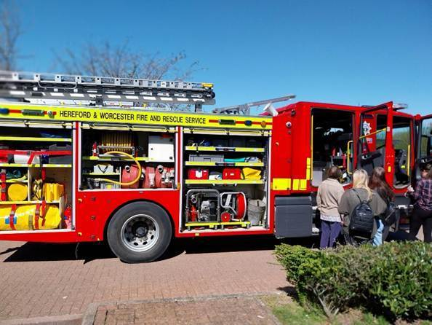
Hereford & Worcester Fire service operates across the two Counties and in 2025/26 attended 8,665 incidents which represented an increase particularly in outdoor fires due to the dry weather. The service has 34 fire engines based at 24 stations with a budget of 44.7 million (raised by Council tax 30.3m, Government grant 9 m, Business rates 3.2m and special grants 2.2m) with 689 staff. The two counties have a joint population of 812,000 in 342,000 households and 36,500 businesses.

Last year in Herefordshire (population 186,000 and 80,000 households) there were 2,047 incidents of which 536 were fires, 662 special incidents including Road traffic, flooding, missing persons, gaining entry etc and 849 false alarms. Of Herefordshire`s 13 stations Hereford is the largest and busiest attending 979 incidents or 48% of all call outs. The Fire service is building a new station in Hereford which should be open in Spring next year.

In addition, the service carries out fire safety inspections of 1,103, nearly 500 building regulations, over 200 fire and post fire investigations and 139 multi agency targeted enforcement operations with Police, customs and excise, immigration teams.
Apart from Hereford all our fire stations rely on part time local people who are invaluable to us to deliver a professional and cost-effective service. The service will improve call filtering and engagement with business to reduce false alarms, work across borders, run programmes on young driver and water safety.

HIGHWAYS
Residents who travel around the County will notice the continued investment in our highways under the council’s current administration and this month will see improvements in Little Dewchurch village. There were rearrangements of timing due to the recent hot weather with more evening working which does increase costs.

With all new re-surfacing utility companies are informed that apart from emergencies disruption to newly laid surfaces will not be allowed. A reminder that with any Utility works on our highways the council has up to two years to make the company make good its repair.

Our Local Community Police Team
Sign up to police alerts, you can choose which areas you want to hear about and what activity is taking place in that area. You'll also hear about positive police action, good news stories and be able to play an active part in helping us with our public appeals.
https://link.edgepilot.com/s/bb21d405/UARq0VNajkqv1vLf0zKSJQ?u=http://www.neighbourhoodmatters.co.uk/
Team contact details
Team email: herefordsouthside.snt@westmercia.police.uk
Safer Neighbourhood Officer: PC 21260 Martin Gillett Mobile: 07970 544262
Safer Neighbourhood Officer: PC 21946 Jack Davies Mobile: 07817 158224
Safer Neighbourhood Officer: PC 2347 Lyn Johnson Mobile: 07773 048377
Safer Neighbourhood Officer: PC 22088 Dan Ovel Mobile: 07929 721340
Safer Neighbourhood Officer: PC 21198 Brian Gosson Mobile: 07973 846336
Police Community Support Officer: PCSO 6324 Carol Marsh Mobile: 07890 524667
Police Community Support Officer: PCSO 40259 Hayley Warne Mobile: 07773 052560
Police Community Support Officer: PCSO 40272 Lewis Thomas Mobile: 07773 051508
We are happy to receive calls from Members of The Public, however, please do not use these to report crimes and/or incidents. For more information on reporting a crime/incident please go to www.westmercia.police.uk and select ‘Report’ or call 999 (Emergency) / 101 (Non-Emergency)

Report a crime Police 101 Ext 61216

HIGHWAYS
PLEASE Report potholes and concerns Al
Report problems on the road –
www.herefordshire.gov.uk/roads-1/report-problems-road
Check on progress of a defect
24/7 Phone number:herefordshire.gov.uk/roads-1/pothole-road-defect-progress-map
Report a serious pothole, flooded road or highway obstruction-: 01432 261800
Making a claim for vehicle damage : www.herefordshire.gov.uk/roads-1/highway-claims
Footpaths issues –
• PROW - PROW@herefordshire.gov.uk
• PROW No – 01432 383 550

Report fly tipping it will be dealt with in a much quicker time frame. by either calling the Contact Centre on 01432 261800 or by logging the fly tipping via the council website on the links below as your www.herefordshire.gov.uk/info/fly_tipping

Road Closures / Restrictions

Ballingham C1267 FROM C1266 TO ROCK FARM
HEREFORDSHIRE COUNCIL
Highway repair and maintenance works
Road closure FL23002563855-01 Granted 06-Aug '26 06-Aug '26

Carey C1267 FROM KILFORGE ROAD TO HAYNES FARM
OPENREACH
Utility repair and maintenance works
Road closure BC518MAPBWWGNRTM7X-01 Submitted 16-Oct '26 16-Oct '26

Carey C1267 FROM KILFORGE ROAD TO HAYNES FARM
OPENREACH
Utility repair and maintenance works
Road closure BC518MAPKFWGTLL90B-01 Submitted 07-Oct '26 07-Oct '26

Carey U72001 BROADWAY LANDS
HEREFORDSHIRE COUNCIL
Highway repair and maintenance works
Road closure FL23001959617-01 Granted 06-Aug '26 06-Aug '26

Carey U72001 BROADWAY LANDS
HEREFORDSHIRE COUNCIL
Highway repair and maintenance works
Road closure FL23019245534-02 Granted 22-Jun '26 01-Jul '26

Dinedor U72011 THE CAMP ROAD
HEREFORDSHIRE COUNCIL
Highway repair and maintenance works
Road closure FL22011902251-01 Granted 11-Aug '26 11-Aug '26

Dinedor U72009 HOLLOW FARM ROAD
WELSH WATER
Utility asset works
Road closure PE11996916704_1-02 Granted 22-Jul '26 24-Jul '26

Dinedor U72009 HOLLOW FARM ROAD
OPENREACH
Utility repair and maintenance works
Road closure BC518MAPBWWGNHJF1P-01 Granted 09-Sep '26 09-Sep '26

Dinedor C1261 FROM UPPER BOWL COTTAGE TO REDBROOK
OPENREACH
Utility asset works
Road closure BC008WG8W523F04SB-03 Granted 03-Aug '26 05-Aug '26

Green Crize U72015 LOWER BULLINGHAM LANE
OPENREACH
Utility asset works
Road closure BC008WG8W533S03SB-04 Granted 27-Jul '26 31-Jul '26

Green Crize C1261 THE PASTURES TO GATEHOUSE ROAD
OPENREACH
Utility asset works
Road closure BC008WG8W533SSB-03 Granted 27-Jul '26 31-Jul '26

Hoarwithy C1267 FROM HOARWITHY TO HAYNES FARM
OPENREACH
Utility repair and maintenance works
Road closure BC518MAPBWWGTLT12R-01 Submitted 16-Oct '26 16-Oct '26

Hoarwithy U71000 TRESSECK MILL ROAD
OPENREACH
Utility asset works
Road closure BC008PLT0036884229032026-01 Submitted 23-Sep '26 23-Sep '26
Holme Lacy B4399 FROM DINEDOR MILL BRIDGE TO B4224
HEREFORDSHIRE COUNCIL
Highway repair and maintenance works
Road closure FL22094728425-01 Submitted 24-Aug '26 24-Aug '26

Holme Lacy B4399 FROM DINEDOR MILL BRIDGE TO B4224
OPENREACH
Utility asset works
Multi-way signals BC008WG9FH57X01SB-01 Granted 06-Jul '26 06-Jul '26

Holme Lacy C1266 FROM B4339 TO SNOWDELL COTTAGE
HEREFORDSHIRE COUNCIL
Highway repair and maintenance works
Road closure FL23036905312-01 Granted 06-Aug '26 06-Aug '26

Holme Lacy B4399 FROM DINEDOR MILL BRIDGE TO B4224
HEREFORDSHIRE COUNCIL
Section 50 Multi-way signals FL012PU2126-01 Granted 22-Jun '26 26-Jun '26

Little Dewchurch C1261 BOGMARSH LANE TO KNAPP GREEN
HEREFORDSHIRE COUNCIL
Highway repair and maintenance works
Road closure FL23098564481-01 Granted 07-Aug '26 07-Aug '26

Little Dewchurch U72001 BROADWAY LANDS
HEREFORDSHIRE COUNCIL
Highway repair and maintenance works
Road closure FL23074960892-01 Granted 06-Aug '26 06-Aug '26

Little Dewchurch U72002 KNAPP GREEN
OPENREACH
Utility asset works
Road closure BC008PLT0036894129032026-01 Granted 24-Aug '26 24-Aug '26

Little Dewchurch U72001 BROADWAY LANDS
HEREFORDSHIRE COUNCIL
Highway repair and maintenance works
Road closure FL23035846707-02 Granted 22-Jun '26 01-Jul '26

Lower Bullingham U72015 LOWER BULLINGHAM LANE
OPENREACH
Utility asset works
Road closure BC008WG8W533S04SB-03 Granted 27-Jul '26 31-Jul '26

Ridgehill C1261 GATEHOUSE ROAD TO REDBROOK
OPENREACH
Utility repair and maintenance works
Road closure BC318HEREFORDBWGSHTW9M-01 Submitted 15-Sep '26 17-Sep '26

Ridgehill U72014 NORTON BROOK ROAD
OPENREACH
Utility asset works
Road closure BC008WG8W523FSB-05 Granted 14-Aug '26 17-Aug '26

Ridgehill U71616 TWYFORD COMMON ROAD FROM THE OAKS TO CHAPEL HOUSE
OPENREACH
Utility asset works
Road closure BC008WG8W523F01SB-05 Granted 06-Aug '26 13-Aug '26

Ridgehill C1261 GATEHOUSE ROAD TO REDBROOK
OPENREACH
Utility asset works
Road closure BC008WG8W523F03SB-03 Granted 03-Aug '26 05-Aug '26

Ridgehill C1261 GATEHOUSE ROAD TO REDBROOK
OPENREACH
Utility asset works
Road closure BC008WG8W533S01SB-03 Granted 27-Jul '26 31-Jul '26

Parish Contacts

Ballingham, Bolstone & Hentland PC clerk@ballinghambolstonehentland-pc.gov.uk

Dinedor PC clerk@dinedorparishcouncil.gov.uk

Holme Lacy PC holmelacyparishclerk@gmail.com

Little Dewchurch PC parish.clerk@littledewchurch.org.uk

Lower Bullingham PC clerk@lowerbullinghamparishcouncil.co.uk

If you want to discuss a planning matter, please contact
planningenquiries@herefordshire.gov.uk

Planning enforcement concern
PlanningEnforcement@herefordshire.gov.uk

Local Emergency Numbers

Environment Agency: 0800 80 70 60 (24-hours) or visit www.gov.uk/report-an-environmental-incident
Flood alerts: Floodline 0345 988 1188. Sign up online at www.gov.uk/sign-up-for-flood-warnings to get Flood Warnings from the Environment Agency by phone, email or text message. If you live by a river or stream, keep a watch on current and expected water levels.

Power cut: Call 105 or visit www.powercut105.com
BT phone line issues: www.downdetector.co.uk/status/bt-british-telecom
Gas leak: 0800 111 999 or visit www.wwutilities.co.uk/services/smell-gas

Welsh Water: 0800 052 0130 (Water emergencies) or 0800 085 3968 (Sewer emergencies) or visit www.contact.dwrcymru.com/

The Citizens Advice Bureau Online at advice@citizensadviceherefordshire.org.uk for initial contact by email. Please also give a contact phone number in case we need to contact you for
more information.

