JUNE UPDATE

BALLSTONE, BALLINGHAM & HENTLAND, DINEDOR, HOLME LACY, LITTLE DEWCHURCH and LOWER BULLINGHAM
DINEDOR HILL WARD
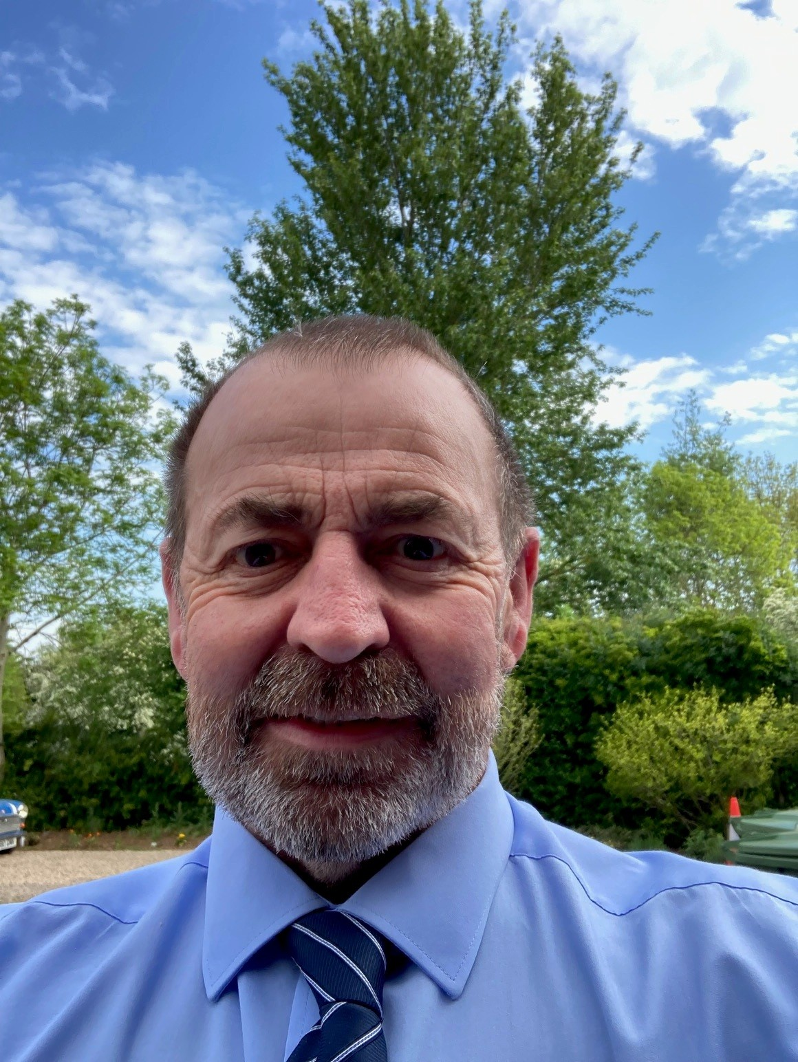
From your local County Councillor

David Davies

david.davies2@herefordshire.gov.uk
Dear Residents

We all know our highways are critical to local authorities and are a huge national issue particularly for rural councils. Beginning today – 1st June - Herefordshire Council has a new highway contractor M Group, replacing Balfour Beatty Living Places, and a new contract which more strongly defines a separation between commissioner of work – the council and its contractor who will deliver – M Group. More details within the update.

We have endured record temperatures for May which saw the recent resurfacing work delayed in some areas due to the temperature being unsuitable for laying tarmac. As we move into summer this month there is a long list of local shows, fetes, community and social events which need our support along with our local businesses. Whether your cheering on England or your friends and family lets ensure whatever else is going on the world on our doorstep’s life is safe and enjoyable. Let’s value what we have and appreciate that it comes together by people giving of their time.

The Council recently received its report from the Care Quality Commission ( CQC) which identifies Improvement needed on waiting times for Care, Financial and Occupational Therapy assessments, delays in accessing some services, particularly equipment and adaptations to homes, and consistent support for unpaid carers.
However safeguarding was rated as Good, with strong quality assurance of care provision, including 77% of home care and 79% of residential providers rated as ‘Good’ or ‘Outstanding’.
The CQC were also positive about the dedicated, professional and compassionate staff who understand local communities and support people to maintain independence, strong partnership working across health, care and community and voluntary sectors, and effective prevention and early support. Adults and Children`s care makes up two thirds of Herefordshire Council`s £234 million budget so we need to ensure it is delivering as positively as possible.
Adult Social Care is a statutory service, making a positive difference to people who need extra support and help across Herefordshire, some with lifelong disabilities. The service supported more than 6,000 adults in 2025, including commissioning care at home or in specialist accommodation for almost 2,900 people. Innovative prevention approaches mean people can live well and as independently as possible, with choice and control over their care. This includes new technology, and physical improvements and adaptations, to more than 4,100 homes annually. Although this rating is not what we wanted, the inspection was at the end of last year and much has already been done to address the issues. We are on the right path and improvements are already identified.

I am pleased to report that Herefordshire Council have deliverer a balanced budget for year end of 2025/26, despite significant funding and demand pressures. The final outturn report, presented to Cabinet on 21 May, confirms that the council ended the year with income and expenditure aligned, reflecting strong financial management and the sustained efforts of services to control spending. That included delivery of £13.2 million in savings while actively managing cost pressures, most notably in adult social care, special educational needs and disabilities (SEND), home-to-school transport and temporary accommodation. This is great credit to our finance team at the council and the Cabinet Member Cllr Peter Stoddard particularly when you considered we have less population than some of our neighbours.

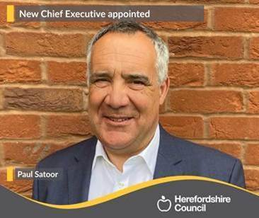
The current Chief Executive of the Council Paul Walker retires this month after over 40 years in public service arriving in Herefordshire in 2021. He has led the council through various challenges and leaves the council in a better place than when he came.

He will be succeeded by Paul Satoor who previously served as Chief Executive of Wirral Council from 2019 to October 2025. A graduate of the University of Wolverhampton, he built his expertise in human resources, organisational development and change through senior roles spanning both the public and private sectors. In June 2013, he joined the Driver and Vehicle Standards Agency (DVSA) as Director of Organisational Development and HR (later deputy chief executive ). His salary is £174,000 per annum, which is one of the lowest amongst first tier English councils, and his appointed, which was the second attempt of recruitment, was supported by all the political group leaders and ratified by the full council of elected members.


During the Hay festival all the local authorities of the Wye catchment area signed a joint agreement on the rights of the river wye. The event took place at the Warren at Hay which is a public area adjoining the river and is probably one of the best public accesses to the river from Plynlimon to the Severn.
The agreement by the public authorities which included Herefordshire, Monmouthshire, Powys, and Forest of Dean is to protect the environment and water quality of the river. While there is concern about the state of the river it is important to ensure that any campaign seeks to genuinely engage and work with all influential sectors for river betterment.
As the event was taking place many people went by on canoes and there were over 50 adults and children swimming in the river reminding us that the Wye still is a great asset.

Left, Deputy Leader of Herefordshire Council Elissa Swindlehurst signs the Charter for the River Wye.

Next year will be our local elections and the Boundary Commission recently published the new ward boundaries for the county. Our Dinedor Hill Ward remains the same as before with no change whatsoever.

In this month’s update I cover the new highway contract, information on Herefordshire very modern University, the latest on Highways plus usual contact lists.

As ever if I can be of any help, please don’t hesitate to contact me.

Stay safe and well

Dave

Goodbye Balfour Beatty - Hello M Group

Following a procurement process Herefordshire has a new contract partner from the 1st June . M Group is a large UK infrastructure services company that specialises in maintaining and improving essential services such as highways, transport and utilities. It will act as the council’s main delivery partner for the new public realm contract, carrying out practical work residents rely on every day, including road maintenance, drainage, street lighting, street cleansing, grass cutting and winter gritting, while operating under a new model where the council retains day-to-day control and commissions work at pre-agreed, transparent rates.

This contract is important because it marks a major shift away from the previous fully outsourced approach (with Balfour Beatty), giving the council greater control, flexibility and accountability over how services are delivered, improving value for money and ensuring that highly visible, day-to-day services that shape residents’ experience of the county are delivered more efficiently, consistently and to a higher standard.

Category one potholes will remain with a 24 hour repair from notification deadline, the new Category 2 potholes have a 28 day repair deadline reduced from six weeks in the previous contract. M Group has also secured the contract to be Welsh Waters contractor in our area which hopefully can improve liaison between the council and Water company.

HIGHWAYS

After my consistent pressure I was pleased to see the long overdue resurfacing of the Holme Lacy Road through Rotherwas has been done. While we no longer have to straddle the white line to avoid the potholes - please watch your speed as the improved road surface may tempt you to drive faster.

Since Easter 100s of potholes have been repaired in my ward and at last for the first time this year we seem to be more on top of the issue. I meet up with our Balfour Locality Steward Mike Gill, to debrief on our outstanding highway issues to ensure a smooth transfer to our new contractors.

Our Local Community Police Team
Sign up to police alerts, you can choose which areas you want to hear about and what activity is taking place in that area. You'll also hear about positive police action, good news stories and be able to play an active part in helping us with our public appeals.
https://link.edgepilot.com/s/bb21d405/UARq0VNajkqv1vLf0zKSJQ?u=http://www.neighbourhoodmatters.co.uk/
Team contact details
Team email: herefordsouthside.snt@westmercia.police.uk
Safer Neighbourhood Officer: PC 21260 Martin Gillett Mobile: 07970 544262
Safer Neighbourhood Officer: PC 21946 Jack Davies Mobile: 07817 158224
Safer Neighbourhood Officer: PC 2347 Lyn Johnson Mobile: 07773 048377
Safer Neighbourhood Officer: PC 22088 Dan Ovel Mobile: 07929 721340
Safer Neighbourhood Officer: PC 21198 Brian Gosson Mobile: 07973 846336
Police Community Support Officer: PCSO 6324 Carol Marsh Mobile: 07890 524667
Police Community Support Officer: PCSO 40259 Hayley Warne Mobile: 07773 052560
Police Community Support Officer: PCSO 40272 Lewis Thomas Mobile: 07773 051508
We are happy to receive calls from Members of The Public, however, please do not use these to report crimes and/or incidents. For more information on reporting a crime/incident please go to www.westmercia.police.uk and select ‘Report’ or call 999 (Emergency) / 101 (Non-Emergency)

Report a crime Police 101 Ext 61216

Scrunch and squeeze, more recycle please!
That’s the big message to Herefordshire residents as Herefordshire Council expands its kerbside recycling service to include foil and tubes, making it even easier to recycle at home.

Now, aluminium foil, foil trays, metal or foil-lined tubes (such as tomato purée tubes), and plastic tubes – including toothpaste and cosmetic tubes – can all be placed in household recycling.
The change makes it easier for residents to recycle common household items that may previously have been thrown away.
- Make sure items are clean and dry
- Squeeze out any remaining product from tube
- Leave lids and caps on tubes
- Put recycling loose in the bin, not in plastic bags
- Scrunch smaller pieces of foil into a ball to help processing


HEREFORDSHIRE`S MODERN UNIVERSITY
The graduation ceremony of Herefordshire engineering university NMITE (New Model Institute for Technology and Engineering), took place in the Cathedral.

The university championed by Jesse Norman MP recruited its first students in 2001 and has a modern and practical style to degree education. There are no lecture theatres, but it relies on hands-on, team based problem solving in engineering and technology. Students work from 9am to 5pm in teams with no long holiday breaks completing degrees faster and entering the workforce earlier.

There is strong collaboration with local businesses with graduate positions and supporting product development. This year NMITE and the British Army announced an agreement to launch an undergraduate degree in autonomous systems (Drones). The university is growing with over 100 graduates starting this year and expansion in coming years.

Herefordshire Council has supported the university which can help regenerate the local economy, address the UK`s skills gap and encourage more young people to study in Herefordshire.

As the graduates received their diplomas and we hear where they are working across UK companies, I was very proud that we have such a model of 21st century education and training in our county.

OUT & ABOUT IN MAY

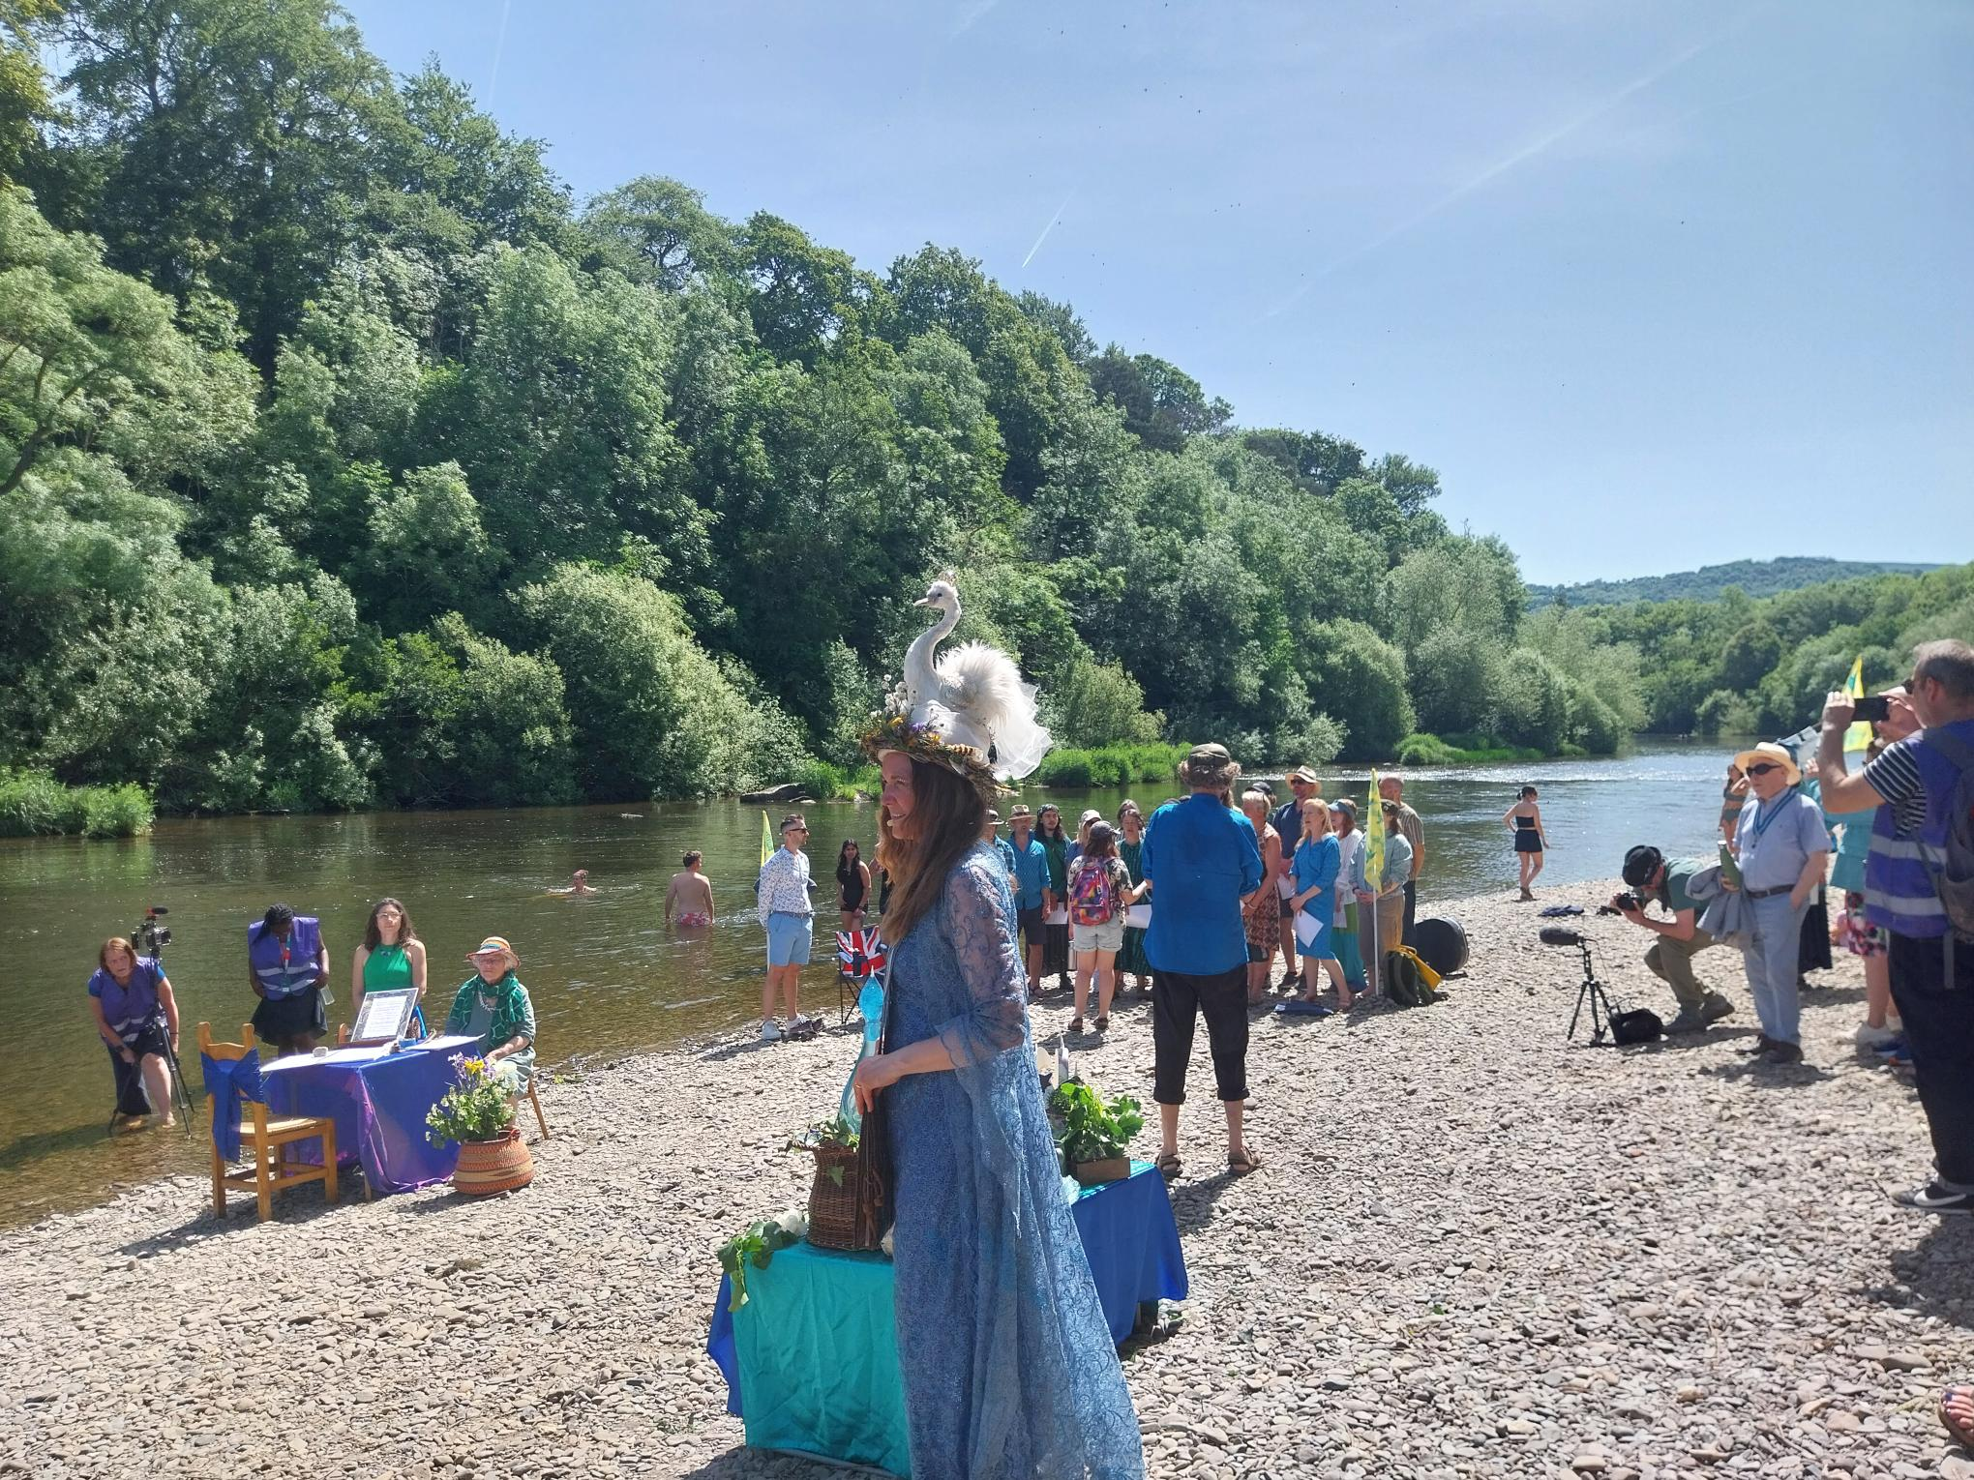

The signing of the river Wye rights charter at the Warren Hay-on-wye

HIGHWAYS
The last Hoarwithy Road Closure Update:
The Section 165 notice to the landowner of Withy Cottage instructing him to demolish the remains of the property has passed on the 29th May. I have been told that Owen Pell has been contracted for the demolition of the remains of the building, but I have not had any further details or clarification. (This is something I am actively chasing)
PLEASE Report potholes and concerns Al
Report problems on the road –
www.herefordshire.gov.uk/roads-1/report-problems-road
Check on progress of a defect
24/7 Phone number:herefordshire.gov.uk/roads-1/pothole-road-defect-progress-map
Report a serious pothole, flooded road or highway obstruction-: 01432 261800
Making a claim for vehicle damage : www.herefordshire.gov.uk/roads-1/highway-claims
Footpaths issues –
• PROW - PROW@herefordshire.gov.uk
• PROW No – 01432 383 550

Report fly tipping it will be dealt with in a much quicker time frame. by either calling the Contact Centre on 01432 261800 or by logging the fly tipping via the council website on the links below as your www.herefordshire.gov.uk/info/fly_tipping

Road Closures

Ballingham C1267 FROM C1266 TO ROCK FARM
HEREFORDSHIRE COUNCIL
Highway repair and maintenance works
Road closure FL23093629099-02 Granted 09-Jun '26 11-Jun '26

Carey U72001 BROADWAY LANDS
HEREFORDSHIRE COUNCIL
Highway repair and maintenance works
Road closure FL23019245534-02 Granted 22-Jun '26 26-Jun '26

Dinedor U72009 HOLLOW FARM ROAD
WELSH WATER
Utility asset works
Road closure PE11996916704_1-01 Granted 22-Jul '26 24-Jul '26

Dinedor C1261 FROM UPPER BOWL COTTAGE TO REDBROOK
OPENREACH
Utility asset works
Road closure BC008WG8W523F04SB-03 Granted 03-Aug '26 05-Aug '26

Green Crize U72015 LOWER BULLINGHAM LANE
OPENREACH
Utility asset works
Road closure BC008WG8W533S03SB-04 Granted 27-Jul '26 31-Jul '26

Green Crize C1261 THE PASTURES TO GATEHOUSE ROAD
OPENREACH Utility asset works
Road closure BC008WG8W533SSB-03 Granted 27-Jul '26 31-Jul '26

Hentland C1234 FROM A49 TO SHEPPON HILL STABLES HOARWITHY OPENREACH
Utility repair and maintenance works
Road closure BC518MAPMDWGTKVK4G-01 Submitted 01-Sep '26 01-Sep '26

Little Dewchurch U72002 KNAPP GREEN
OPENREACH
Utility asset works
Road closure BC008PLT0036894129032026-01 Submitted 24-Aug '26 24-Aug '26

Little Dewchurch C1261 BOGMARSH LANE TO KNAPP GREEN HEREFORDSHIRE COUNCIL
Highway improvement works
Two-way signals FL012PU2083-04 Granted 18-May '26 27-May '26

Little Dewchurch U72001 BROADWAY LANDS
HEREFORDSHIRE COUNCIL
Highway repair and maintenance works
Road closure FL23035846707-02 Granted 22-Jun '26 26-Jun '26

Lower Bullingham U72015 LOWER BULLINGHAM LANE
OPENREACH
Utility asset works
Road closure BC008WG8W533S04SB-03 Granted 27-Jul '26 31-Jul '26

Ridgehill U72014 NORTON BROOK ROAD
OPENREACH
Utility asset works
Road closure BC008WG8W523FSB-05 Submitted 14-Aug '26 17-Aug '26

Ridgehill U71616 TWYFORD COMMON ROAD FROM THE OAKS TO CHAPEL HOUSE
OPENREACH
Utility asset works
Road closure BC008WG8W523F01SB-05 Submitted 06-Aug '26 13-Aug '26

Ridgehill C1261 GATEHOUSE ROAD TO REDBROOK
OPENREACH
Utility asset works
Road closure BC008WG8W523F03SB-03 Submitted 03-Aug '26 05-Aug '26

Ridgehill C1261 GATEHOUSE ROAD TO REDBROOK
OPENREACH
Utility asset works
Road closure BC008WG8W533S01SB-03 Submitted 27-Jul '26 31-Jul '26

Parish Contacts

Ballingham, Bolstone & Hentland PC clerk@ballinghambolstonehentland-pc.gov.uk

Dinedor PC clerk@dinedorparishcouncil.gov.uk

Holme Lacy PC holmelacyparishclerk@gmail.com

Little Dewchurch PC parish.clerk@littledewchurch.org.uk

Lower Bullingham PC clerk@lowerbullinghamparishcouncil.co.uk

If you want to discuss a planning matter, please contact
planningenquiries@herefordshire.gov.uk

Planning enforcement concern
PlanningEnforcement@herefordshire.gov.uk

Local Emergency Numbers

Environment Agency: 0800 80 70 60 (24-hours) or visit www.gov.uk/report-an-environmental-incident
Flood alerts: Floodline 0345 988 1188. Sign up online at www.gov.uk/sign-up-for-flood-warnings to get Flood Warnings from the Environment Agency by phone, email or text message. If you live by a river or stream, keep a watch on current and expected water levels.

Power cut: Call 105 or visit www.powercut105.com
BT phone line issues: www.downdetector.co.uk/status/bt-british-telecom
Gas leak: 0800 111 999 or visit www.wwutilities.co.uk/services/smell-gas

Welsh Water: 0800 052 0130 (Water emergencies) or 0800 085 3968 (Sewer emergencies) or visit www.contact.dwrcymru.com/

The Citizens Advice Bureau Online at advice@citizensadviceherefordshire.org.uk for initial contact by email. Please also give a contact phone number in case we need to contact you for
more information.

