MAY UPDATE

BALLSTONE, BALLINGHAM & HENTLAND, DINEDOR, HOLME LACY, LITTLE DEWCHURCH and LOWER BULLINGHAM
DINEDOR HILL WARD

From your local County Councillor

David Davies

david.davies2@herefordshire.gov.uk
Dear Residents

As we enter the final month of the Balfour Beatty contract the issue of potholes still remains the chief concern of many residents. I am pleased to report extensive work on the Holme Lacy to Ballingham Road, but lots still remain and an inheritance for our new contractors M Power on the 1st June.

The Council were intending to begin a Food waste collection from 1st April but this is delayed as we were expecting along with other local authorities’ financial support from the government. The revenue cost to us would be 2.3 million pounds per annum and we should have received this funding as a new burden agreement. We are therefore having to confirm funding, review governance as the Cabinet decision was to implement the change subject to ‘new burdens’ funding being made available and review our implementation plans and timescales to align with these changes.

However good news our recycling rate (green bins) has remained at 39%, despite a national trend of falling rates, and you can now recycle aluminium foil, foil trays, metal and foiled lined tubes and plastic tubes.

I am pleased to support the Council in investigating the creation of a digital officer post to take on the responsibility for broadband provision across the county, management of our terrestrial mobile phone coverage and supporting the take up of new and improved digital services across the county. Despite the massive Fastershire investment to improve access to high-speed broadband, it is still an issue for so many as is poor mobile coverage, having an officer to specialise in this is important particularly for rural communities and businesses.

The national media is very focused on the upcoming local elections a reminder there are NO local elections in Herefordshire this year. Herefordshire Council and Parish elections are held every four years – next elections May 6th 2027 with the Boundary Commission recently confirming no changes to our ward or parishes.

In this month’s update I cover, the recent Tourism Conference, the latest on Highways, report some of the financial pressures facing the council and also outline some of the work Herefordshire Council is doing to support the River Wye, its tributaries and catchment plus usual contacts.

As ever if I can be of any help, please don’t hesitate to contact me.

Stay safe and well

Dave

Visit HEREFORDSHIRE – Annual Tourism Conference
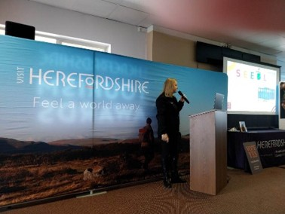
The annual conference of the organisation that promotes tourism for Herefordshire attended by 220 local people. It is estimated that tourism is worth 830 million pounds to our local economy with 9% of the county employees.

Visit Herefordshire is a voluntary organisation run by local tourism leads who raise an extra precept on larger tourism business to fund their activity. They offer support to local businesses on reducing costs, including Business Rate Support service; organise over 2000 training courses in person and on online and develop marketing strategies to promote the county.

Working with the Council they helped secure film locations for Hamnet in Weobley and Brilley which is estimated over two months was worth over 800,000 to local economy.
Visit Herefordshire use AI and technologies to gather evidence of visitor movements and spend which helps direct county wide and individual business future planning. Among recent campaigns are Local producer branding, Dog friendly status, Inn to Inn and Herefordshire wine tourism.

Going forward priorities include extending visitor stays in our county from weekend breaks to longer periods, targeting promotion to certain areas of the country, focusing on “empty nesters” and mature families as the prime market, and more active holidays in July and August for families.

A very impressive conference supporting the thousands of small tourism and hospitality businesses in our county.

MALVERN SPRING GARDEN SHOW 10TH- 12 TH MAY
Royal Three County Show Ground
Largest Horticultural event in West Midlands
Book tickers online beforehand

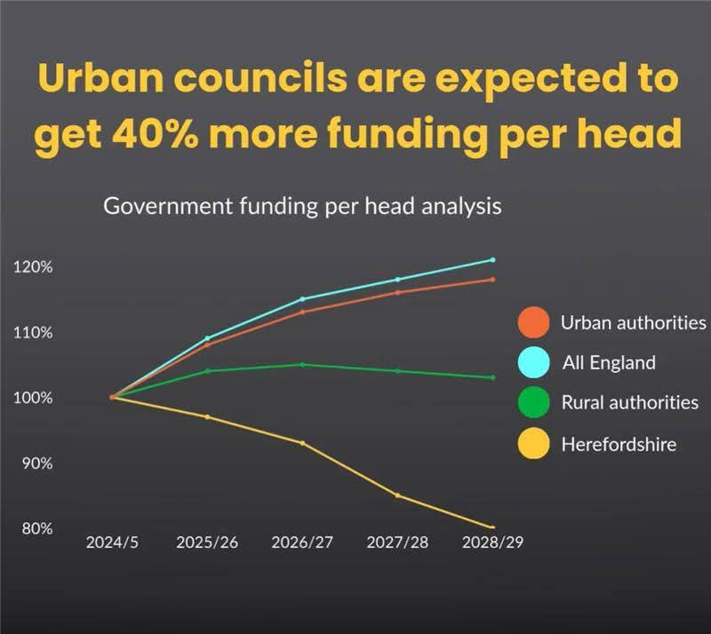
HARD FINANCIAL REALITY
Herefordshire Council`s revenue budget for 2026/27 totals £234.1M and includes a 4.99% increase in total council tax. Significantly better than either Worcestershire or Shropshire who are also borrowing funds from the Government and paying extra interest.

The Government`s (un) Fair Funding review of local government budgets has ensured Urban councils are expected to receive around 32% more per head in Government-funded spending power for 2026/27. That rural residents will pay around 17% more in council tax compared to Urban residents in 2026/27. That by 2028/29, urban authorities’ spending power is expected to allow them to spend around £100 more per resident on services than the most rural councils and that by 2028/29, Government-funded spending power for the most urban authorities is estimated to rise by around 20%, compared with around 2% for the most rural councils. Worth noting that Birmingham City Council a Labour ran local authority which was bankrupt, now states that its financial situation for 2026-27 will be "balanced", with services set for £130m investment. I think this shows the true impact of the fair funding review which moves funding from rural to urban authorities.

We in Herefordshire will be required to make £20M of savings which will be met by controlling costs of service delivery, increasing income from fees and charges, managing demand for council services in high-cost, demand led budgets (an example is entering into long-term agreements with care home providers which can enable £2.5M of savings) and finally delivering efficiencies through review and transformation of services (use of AI in support of social workers reduces their time spent writing up minutes of interviews and thus makes them more efficient.) Of the £20M of savings, 35% or £6.9M are expected to be delivered on 1 April.

The Council has to also start work on plans for the 27/28 budget and its required savings of another £20M !

Protecting the River Wye and its tributaries


Herefordshire Council has agreed a Charter for the Wye and will integrate it into polices and decision- making where possible including the new Local Plan.

The Council will continue to prioritise freshwater recovery, including tackling pollution, restoring wetlands, reconnecting habitats and improving river systems at a catchment scale, in line with the Local Nature Recovery Strategy and Council Plan.

The Council will support neighbouring authorities in championing the Charter, promoting a cross-border, catchment wide approach to protecting the River Wye and its tributaries and publicising this shared commitment.

Wye Valley National Landscape Projects includes £1.6–£1.8 million of funding supporting an annual programme delivery, combining DEFRA, Welsh Government, National Grid and other grants, which allow multiple landscape-scale projects to run alongside community and farming initiatives including:

Farming in Protected Landscapes (FiPL) – 2025/26 delivery
The FiPL programme supported 43 projects with 40 farmers, delivering 27.5 hectares of wildflower meadow, 1,863 trees, 772 metres of hedgerow, 8 ponds, and 5 leaky dams, alongside livestock management improvements, fencing and farmer advice days

National Grid Landscape Enhancement Initiative (LEI)
Three major LEI projects (2025–2028, total £792k) are improving landscape and biodiversity following electric cable undergrounding with new and restored hedgerows, species-rich grassland, orchard and parkland trees, and wetland and natural flood management features including ponds and leaky dams delivered during 2025.

Lower Wye Nature recovery and climate adaptation projects
Practical measures are being delivered across the Lower Wye, including habitat creation, woodland and orchard planting, and natural flood management, linking biodiversity recovery with climate resilience and water management.

FCC Biodiversity Community Grant Scheme
The grant aims to protect and enhance biodiversity through allocating funding to projects which will deliver environmental improvements and initiatives that create green spaces, improve biodiversity or help ecosystems in Herefordshire.

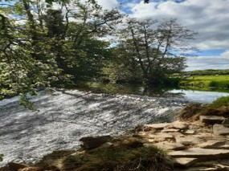
Example projects include tree and hedge planting or management, creation of wildlife corridors, bird, bat or bug boxes and hedgehog homes, planting wildflower areas, wetland / pond creation. Projects should include community / public benefit and engagement.

During 2025 a total of almost £62,000 funding was awarded to 12 successful applicants in the county including citizen science bat survey, Southside Farm community nature areas, biological heritage at Snodhill Castle and Oatleys Meadow destination park.

The grant scheme will re-open to applications from 1 June 2026 and I hope will be of interest locally.

Our Local Community Police Team
Sign up to police alerts, you can choose which areas you want to hear about and what activity is taking place in that area. You'll also hear about positive police action, good news stories and be able to play an active part in helping us with our public appeals.
https://link.edgepilot.com/s/bb21d405/UARq0VNajkqv1vLf0zKSJQ?u=http://www.neighbourhoodmatters.co.uk/
Team contact details
Team email: herefordsouthside.snt@westmercia.police.uk
Safer Neighbourhood Officer: PC 21260 Martin Gillett Mobile: 07970 544262
Safer Neighbourhood Officer: PC 21946 Jack Davies Mobile: 07817 158224
Safer Neighbourhood Officer: PC 2347 Lyn Johnson Mobile: 07773 048377
Safer Neighbourhood Officer: PC 22088 Dan Ovel Mobile: 07929 721340
Safer Neighbourhood Officer: PC 21198 Brian Gosson Mobile: 07973 846336
Police Community Support Officer: PCSO 6324 Carol Marsh Mobile: 07890 524667
Police Community Support Officer: PCSO 40259 Hayley Warne Mobile: 07773 052560
Police Community Support Officer: PCSO 40272 Lewis Thomas Mobile: 07773 051508
We are happy to receive calls from Members of The Public, however, please do not use these to report crimes and/or incidents. For more information on reporting a crime/incident please go to www.westmercia.police.uk and select ‘Report’ or call 999 (Emergency) / 101 (Non-Emergency)

Report a crime Police 101 Ext 61216

HIGHWAYS
The last Hoarwithy Road Closure Update from HC:

Update on Hoarwithy Road Closure – Withy Cottage
We wanted to update you on the ongoing closure of Hoarwithy Road at Withy Cottage and the steps being taken to resolve the situation.
The Council’s priority throughout has been to ensure public and highway safety. Following initial concerns about the stability of Withy Cottage, Building Control used its legal powers to require partial demolition of the structure to remove the most immediate risk.
Whilst the most immediate risk has been removed, specialist technical assessments have identified the potential for further land movement behind the site. This could lead to further impact on Withy Cottage, leading to debris or masonry falling into the road, creating a continued safety risk for highway users.
As a result, the matter has appropriately transferred from Building Control to the Council’s Highways team who have issued a formal notice to the landowner under Section 165 of the Highways Act. This requires the landowner to remove or make safe the remaining structure to eliminate the risk to the highway and enable the road to reopen safely.
The notice sets out clear expectations and timescales:
• The landowner is required to confirm their proposed course of action by 8 May
• The necessary works must be completed by 29 May
If these requirements are not met, the Council has the power to carry out the works directly and recover the costs.
We recognise the frustration and disruption this closure is causing to residents, businesses and visitors, particularly with the approaching Bank Holiday period. We will continue to keep you updated on progress throughout this process.
Our focus now is on securing a safe and timely resolution, minimising disruption wherever possible, and keeping members of the local community informed as the situation progresses.

I am in constant communication with senior Council Officers doing everything I can to expedite the situation. As things progress, I will try to keep you informed as soon as possible.

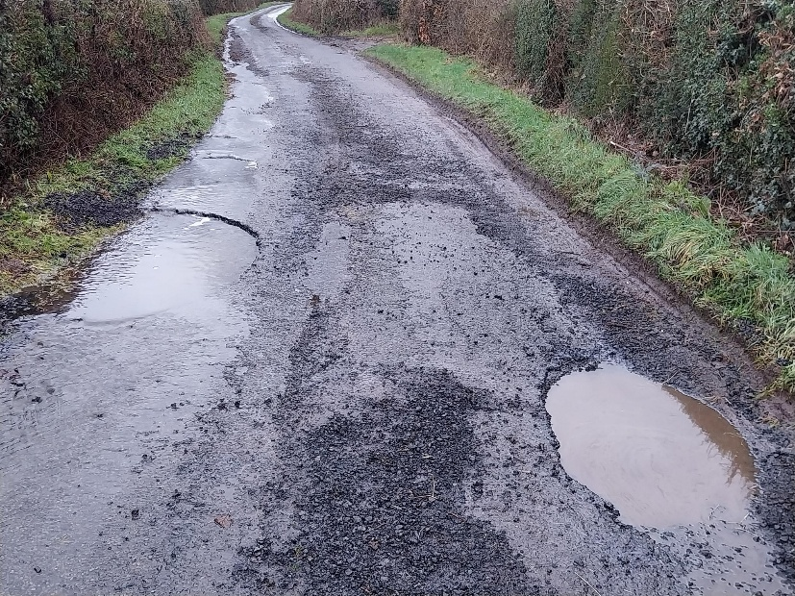
PLEASE report potholes and concerns Al
Report problems on the road –
www.herefordshire.gov.uk/roads-1/report-problems-road

Check on progress of a defect
number:herefordshire.gov.uk/roads-1/pothole-road-defect-progress-map
Report a serious pothole, flooded road or highway obstruction- Balfour Beatty Living Places : 01432 261800
Making a claim for vehicle damage : www.herefordshire.gov.uk/roads-1/highway-claims
Footpaths issues –
• PROW - PROW@herefordshire.gov.uk
• PROW No – 01432 383 550

Report fly tipping it will be dealt with in a much quicker time frame. by either calling the Contact Centre on 01432 261800 or by logging the fly tipping via the council website on the links below as your www.herefordshire.gov.uk/info/fly_tipping

Road Closures

Ballingham C1267 FROM C1266 TO ROCK FARM
HEREFORDSHIRE COUNCIL
Highway repair and maintenance works
Road closure FL23093629099-01 Granted 09-Jun '26 11-Jun '26

Carey U72001 BROADWAY LANDS
HEREFORDSHIRE COUNCIL
Highway repair and maintenance works
Road closure FL23019245534-01 Granted 22-Jun '26 26-Jun '26

Dinedor U72009 HOLLOW FARM ROAD
WELSH WATER
Utility asset works
Road closure PE11996916704_1-01 Submitted 22-Jul '26 24-Jul '26

Dinedor C1261 FROM UPPER BOWL COTTAGE TO REDBROOK
OPENREACH
Utility asset works
Road closure BC008WG8W523F04SB-03 Submitted 03-Aug '26 05-Aug '26

Green Crize U72015 LOWER BULLINGHAM LANE
OPENREACH
Utility asset works
Road closure BC008WG8W533S03SB-04 Submitted 27-Jul '26 31-Jul '26

Green Crize C1261 THE PASTURES TO GATEHOUSE ROAD
OPENREACH
Utility asset works
Road closure BC008WG8W533SSB-03 Submitted 27-Jul '26 31-Jul '26

Little Dewchurch U72001 BROADWAY LANDS
HEREFORDSHIRE COUNCIL
Highway repair and maintenance works
Road closure FL23035846707-01 Granted 22-Jun '26 26-Jun '26

Lower Bullingham U72015 LOWER BULLINGHAM LANE
OPENREACH
Utility asset works
Road closure BC008WG8W533S04SB-03 Submitted 27-Jul '26 31-Jul '26

Ridgehill U72014 NORTON BROOK ROAD
OPENREACH
Utility asset works
Road closure BC008WG8W523FSB-05 Submitted 14-Aug '26 17-Aug '26

Ridgehill U71616 TWYFORD COMMON ROAD FROM THE OAKS TO CHAPEL HOUSE
OPENREACH
Utility asset works
Road closure BC008WG8W523F01SB-05 Submitted 06-Aug '26 13-Aug '26

Ridgehill C1261 GATEHOUSE ROAD TO REDBROOK
OPENREACH
Utility asset works
Road closure BC008WG8W523F03SB-03 Submitted 03-Aug '26 05-Aug '26

Ridgehill C1261 GATEHOUSE ROAD TO REDBROOK
OPENREACH
Utility asset works
Road closure BC008WG8W533S01SB-03 Submitted 27-Jul '26 31-Jul '26

Rotherwas U72022 NETHERWOOD ROAD
HEREFORDSHIRE COUNCIL
Highway improvement works
Road closure FL22077163999-02 Submitted 05-May '26 23-May '26

Rotherwas CHAPEL ROAD
HEREFORDSHIRE COUNCIL
Highway improvement works
Road closure FL22044917615-02 Submitted 05-May '26 23-May '26

Rotherwas C1268 HOLME LACY ROAD
HEREFORDSHIRE COUNCIL
Highway repair and maintenance works
Road closure FL22066619072-02 Submitted 05-May '26 23-May '26

Rotherwas B4399 FROM GATEHOUSE ROAD TO ROTHERWOOD
HEREFORDSHIRE COUNCIL
Highway repair and maintenance works
Road closure FL22099795906-02 Submitted 05-May '26 23-May '26

………………………….

Parish Contacts

Ballingham, Bolstone & Hentland PC clerk@ballinghambolstonehentland-pc.gov.uk

Dinedor PC clerk@dinedorparishcouncil.gov.uk

Holme Lacy PC holmelacyparishclerk@gmail.com

Little Dewchurch PC parish.clerk@littledewchurch.org.uk

Lower Bullingham PC clerk@lowerbullinghamparishcouncil.co.uk

If you want to discuss a planning matter, please contact
planningenquiries@herefordshire.gov.uk

Planning enforcement concern
PlanningEnforcement@herefordshire.gov.uk

Local Emergency Numbers

Environment Agency: 0800 80 70 60 (24-hours) or visit www.gov.uk/report-an-environmental-incident
Flood alerts: Floodline 0345 988 1188. Sign up online at www.gov.uk/sign-up-for-flood-warnings to get Flood Warnings from the Environment Agency by phone, email or text message. If you live by a river or stream, keep a watch on current and expected water levels.

Power cut: Call 105 or visit www.powercut105.com
BT phone line issues: www.downdetector.co.uk/status/bt-british-telecom
Gas leak: 0800 111 999 or visit www.wwutilities.co.uk/services/smell-gas

Welsh Water: 0800 052 0130 (Water emergencies) or 0800 085 3968 (Sewer emergencies) or visit www.contact.dwrcymru.com/

The Citizens Advice Bureau Online at advice@citizensadviceherefordshire.org.uk for initial contact by email. Please also give a contact phone number in case we need to contact you for
more information.

