APRIL UPDATE

BALLSTONE, BALLINGHAM & HENTLAND, DINEDOR, HOLME LACY, LITTLE DEWCHURCH and LOWER BULLINGHAM
DINEDOR HILL WARD
From your local County Councillor
David Davies
david.davies2@herefordshire.gov.uk
Dear Residents

Back in May 2023 I began to send out monthly updates to my parishes, mainly verbal and then written. The reports now form the basis of my Parish Council reports, although I know not always read.

I hope most of you find them of value and recognise my commitment to you as your local representative.

The Lord Lieutenant Edward Harley presented the C.EX of Herefordshire Council Paul Walker with a Gold Award from the Armed Forces Covenant; in recognition of what the local authority does to support the armed forces, their families and veterans in the county.
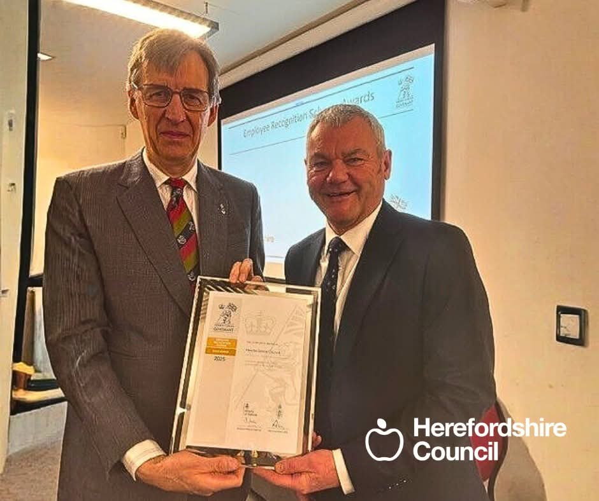
Over 180 businesses and organisations in Herefordshire are recognised by the Covenant reflecting the important role defence and the military plays in our county.

In this month`s update I cover the appointment of contractors for the first section of the Hereford Bypass, mark the latest phase of the new Hereford Fire Station, raising concerns of increased business rates on our local businesses with our MP, financial support for households off grid, Highways and the usual local contacts.

As ever if I can be of any help, please don’t hesitate to contact me.

Stay safe and well

Dave

FIRST SECTION OF HEREFORD BYPASS BEGINS THIS DECEMBER

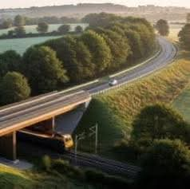
Herefordshire Council has appointed Civil engineering firm, Graham as the contractor to undertake detailed design and early technical work for the first phase of the Hereford Bypass, paving the way for construction to begin by December this year.
Following a comprehensive tender process launched last year, the contractor will work on the project, which will see a new road linking the A49 and A465 to the south-west of Hereford.A further tender process will see the final construction contract being awarded in the summer.

The new 3.6km single carriageway road will link the A49/Ross Road–Rotherwas Access Road roundabout with the A465 Abergavenny Road and provide a connection onwards to the B4349 Clehonger Road, completion in 2028. The scheme includes a series of underpasses and structures, including a new bridge over the Hereford-Newport railway line, to maintain regional and local access, and provision for walkers, cyclists, equestrians and wildlife.
The new highway will help reduce congestion at Asda roundabout and Belmont and open up the next phase of linking to the A49 to the west of the city.
The disappointment of course, is that the Government had originally given the money for this section of highway but the change in Herefordshire politics in 2019-23 meant the money was handed back to Government and the purchased land sold back. Now the land is being repurchased and the funding borrowed by the Council. More details https://www.herefordshire.gov.uk/back-the-bypass

NEW HEREFORD FIRE STATION ON TARGET

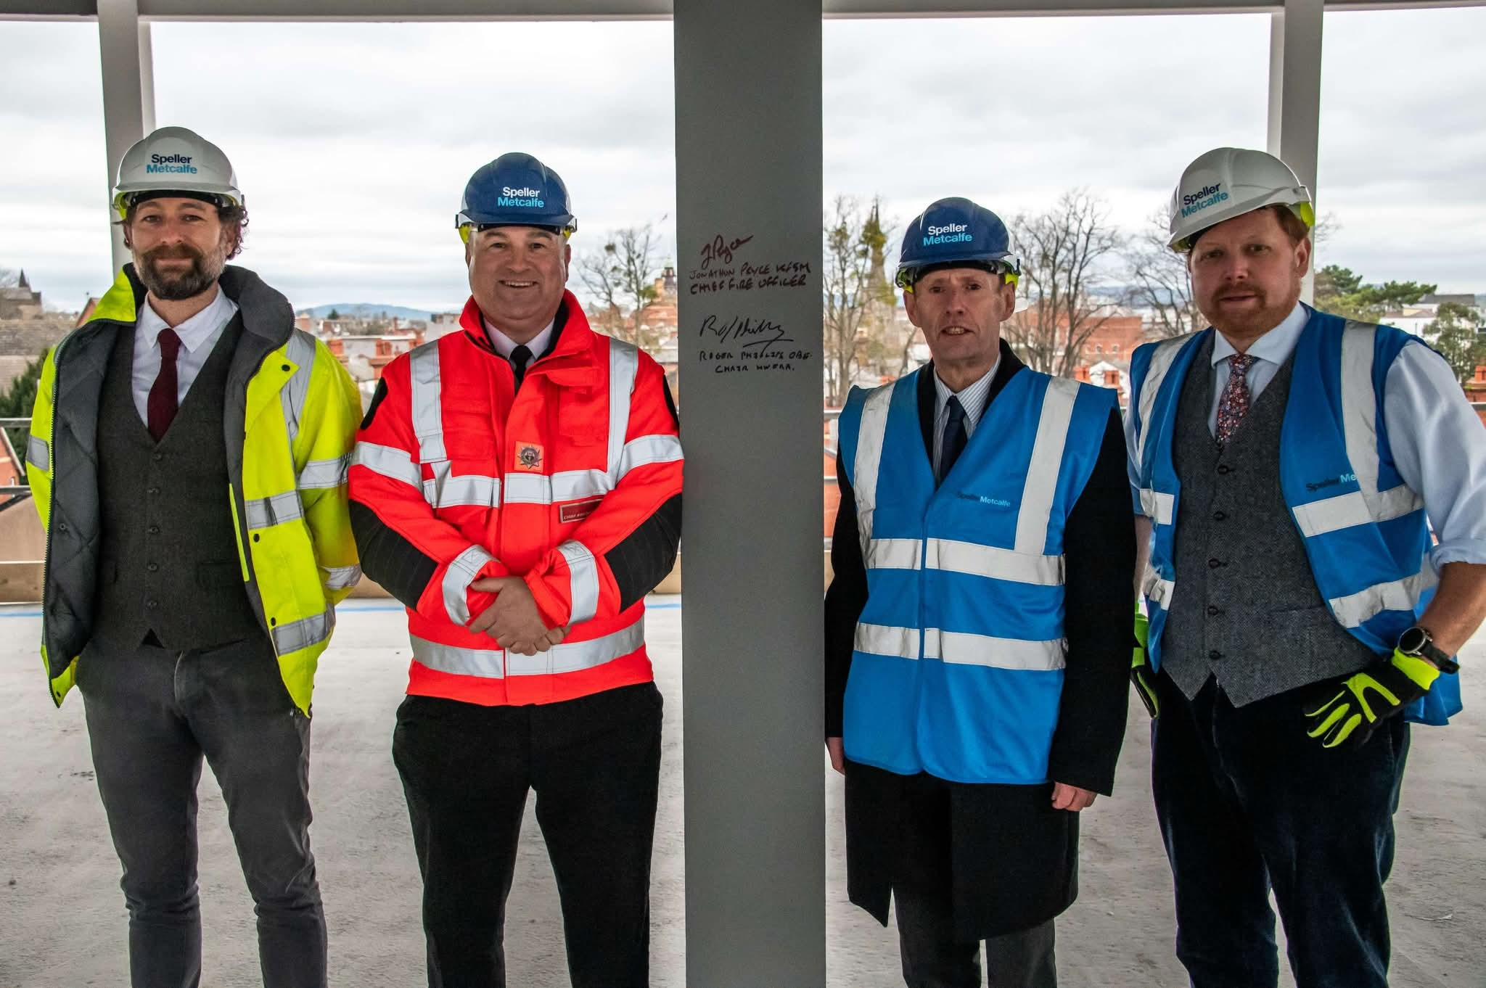
Cllr Roger Phillips as well as being Chairman of Herefordshire Council is also Chairman of the Hereford and Worcester Fire Authority. He joined the Fire Chief Jon Pryce and representatives of our contractors Speller Metcalfe to sign the steel marking the completion of the steel erection stage of the four-storey building.

They searched for sites for over 15 years to replace the old 1951 building trying to identify other sites but had to build on our existing site. Despite the weather and a restricted area the project is on time with hand over forecast at the end of the year and following fit out we should be moving in and operating from next March.

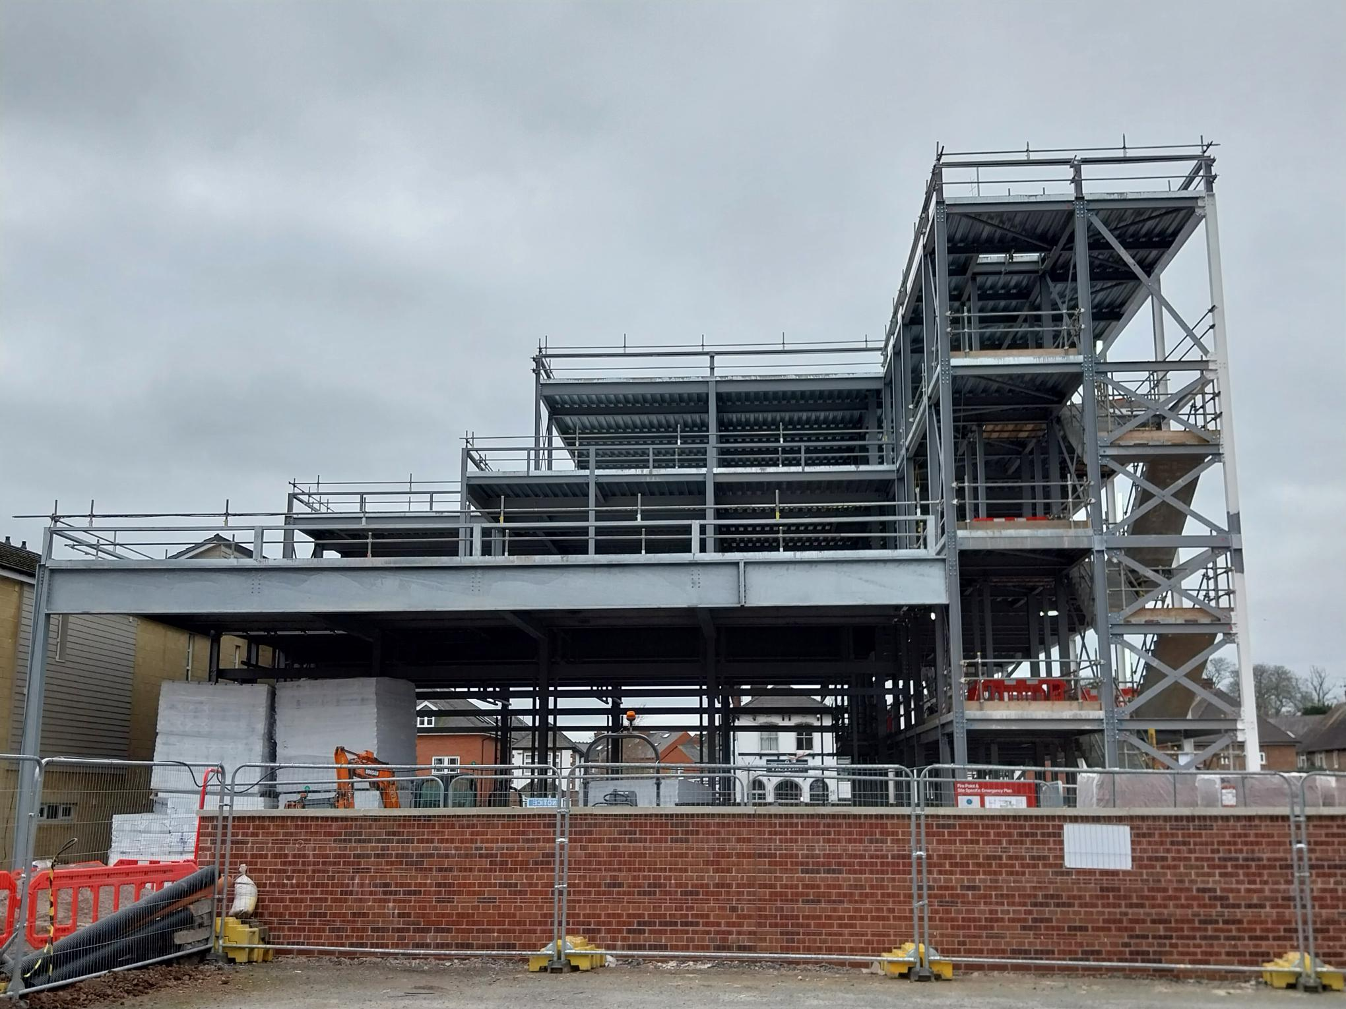
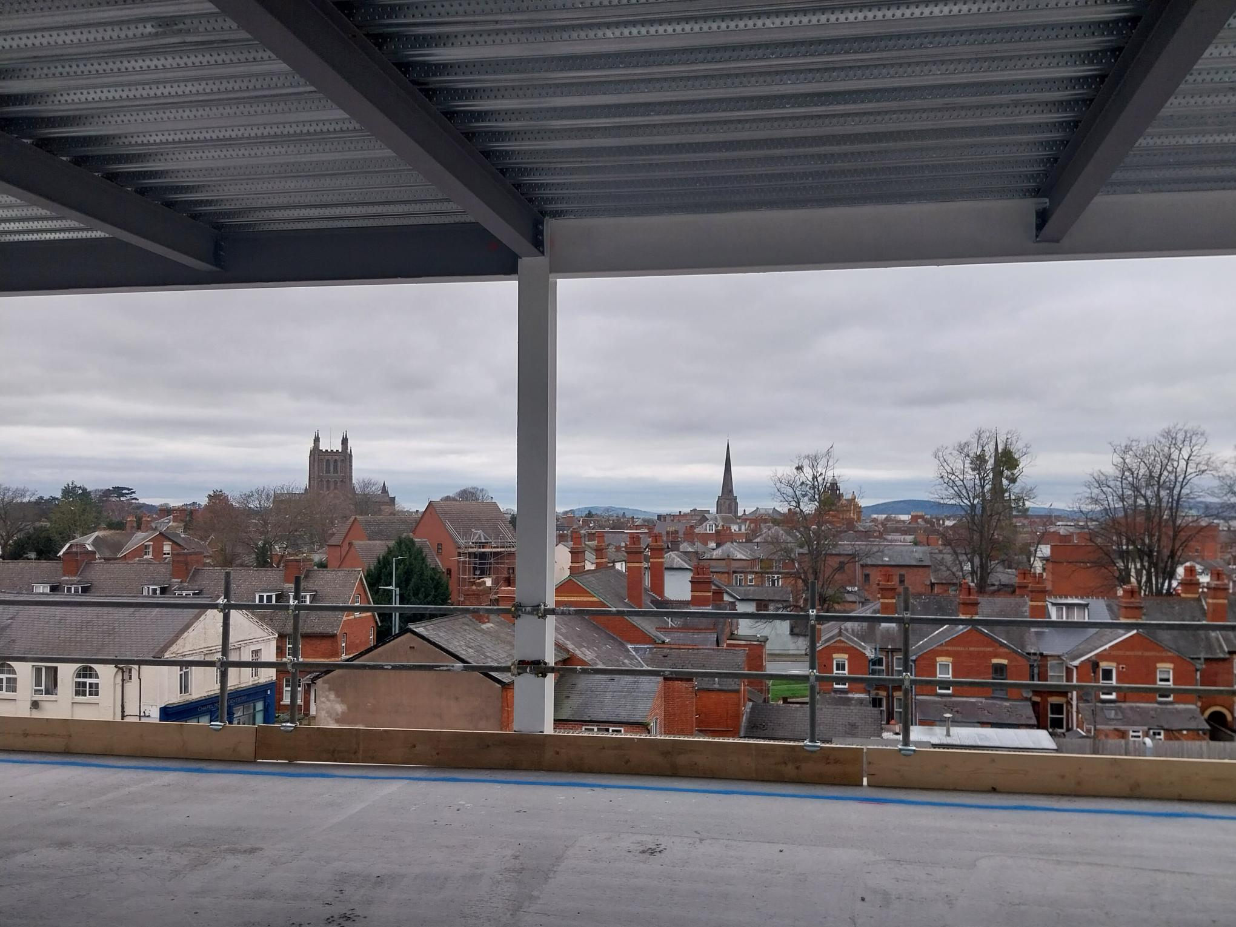
Hereford has the only two full time crews in the County with all our other ten stations all crewed by on-call retained firefighters from the community. The four-storey new build is one of the highest buildings in the City- as the picture below shows the fourth floor is the same height as Cathedral Tower.

Huge Increases in Business Rates Hits our Local Businesses.

The Government issued new increased business rates this year and local business have seen some huge rises in their bills.

All sectors have been hit, with a local haulage business seeing its business rates rise from 22k to 85K, but in particular we focused on the hospitality and tourism business.

The 542 tourism businesses who pay a levy to Visit Herefordshire to promote local tourism saw their business valuations increase by 4.7 million pounds and there are a further 2,500 other smaller business in the county.

Meanwhile the local supermarkets have seen increases in line with inflation despite their size and ability to absorb cost pressures.

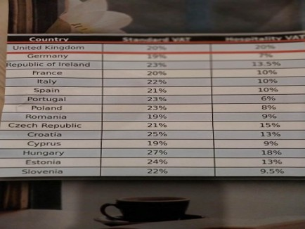
Another issue raised was the difference across Europe on VAT taxes with most countries imposing VAT at half the 20% rate of the UK. See figures in photograph.These increases come on the back of the rise in National Insurance and the lowering of their thresholds, increases in the minimum wage, utility costs and leave many of our small business with very small margins. The message is clear we need to support our local businesses or loose them

Our MP has written to the Treasury on the matter, and we wait to see their response.

Support for rising Energy costs for rural areas
I was pleased that DEFRA contacted the Rural Services Network regarding the impact of off grid oil and gas price increases as a result of the USA/Iran war on rural communities. Homes in the countryside are not connected to national networks and therefore are outside government price control legislation. The problem is finding a scheme to support rural areas that is practical to deliver hence the targeting of low-income families who are already in the system. Based on the 2021 UK census Herefordshire has more than 13,600 homes using solely oil heating and nearly 3,000 on LGP. (18% of all households).
It means an estimated 18% of the total 88,000 properties. Herefordshire Council has secured £517,865 additional funding from government to help low-income households afford the huge increases in cost of oil and LPG. One national average price cited has highlighted the cost of LPG rising from 67pence to £1.45 per litre in recent weeks. Eligibility for financial support through the fund is based on criteria aligned to the council’s existing Warm Homes Local Grant Programme. Households receive funding covering a proportion of the difference in cost between their previous average bills and the current price: household incomes £36,000 or below - 100%; £36,000 - £50,000 - 50%. Details on Council`s website.

Our Local Community Police Team
Sign up to police alerts, you can choose which areas you want to hear about and what activity is taking place in that area. You'll also hear about positive police action, good news stories and be able to play an active part in helping us with our public appeals.
https://link.edgepilot.com/s/bb21d405/UARq0VNajkqv1vLf0zKSJQ?u=http://www.neighbourhoodmatters.co.uk/
Team contact details
Team email: herefordsouthside.snt@westmercia.police.uk
Safer Neighbourhood Officer: PC 21260 Martin Gillett Mobile: 07970 544262
Safer Neighbourhood Officer: PC 21946 Jack Davies Mobile: 07817 158224
Safer Neighbourhood Officer: PC 2347 Lyn Johnson Mobile: 07773 048377
Safer Neighbourhood Officer: PC 22088 Dan Ovel Mobile: 07929 721340
Safer Neighbourhood Officer: PC 21198 Brian Gosson Mobile: 07973 846336
Police Community Support Officer: PCSO 6324 Carol Marsh Mobile: 07890 524667
Police Community Support Officer: PCSO 40259 Hayley Warne Mobile: 07773 052560
Police Community Support Officer: PCSO 40272 Lewis Thomas Mobile: 07773 051508
We are happy to receive calls from Members of The Public, however, please do not use these to report crimes and/or incidents. For more information on reporting a crime/incident please go to www.westmercia.police.uk and select ‘Report’ or call 999 (Emergency) / 101 (Non-Emergency)

Report a crime Police 101 Ext 61216

HIGHWAYS
The state of our highways is a major concern this year and I am battling to get surfacing and repairs done in my ward.

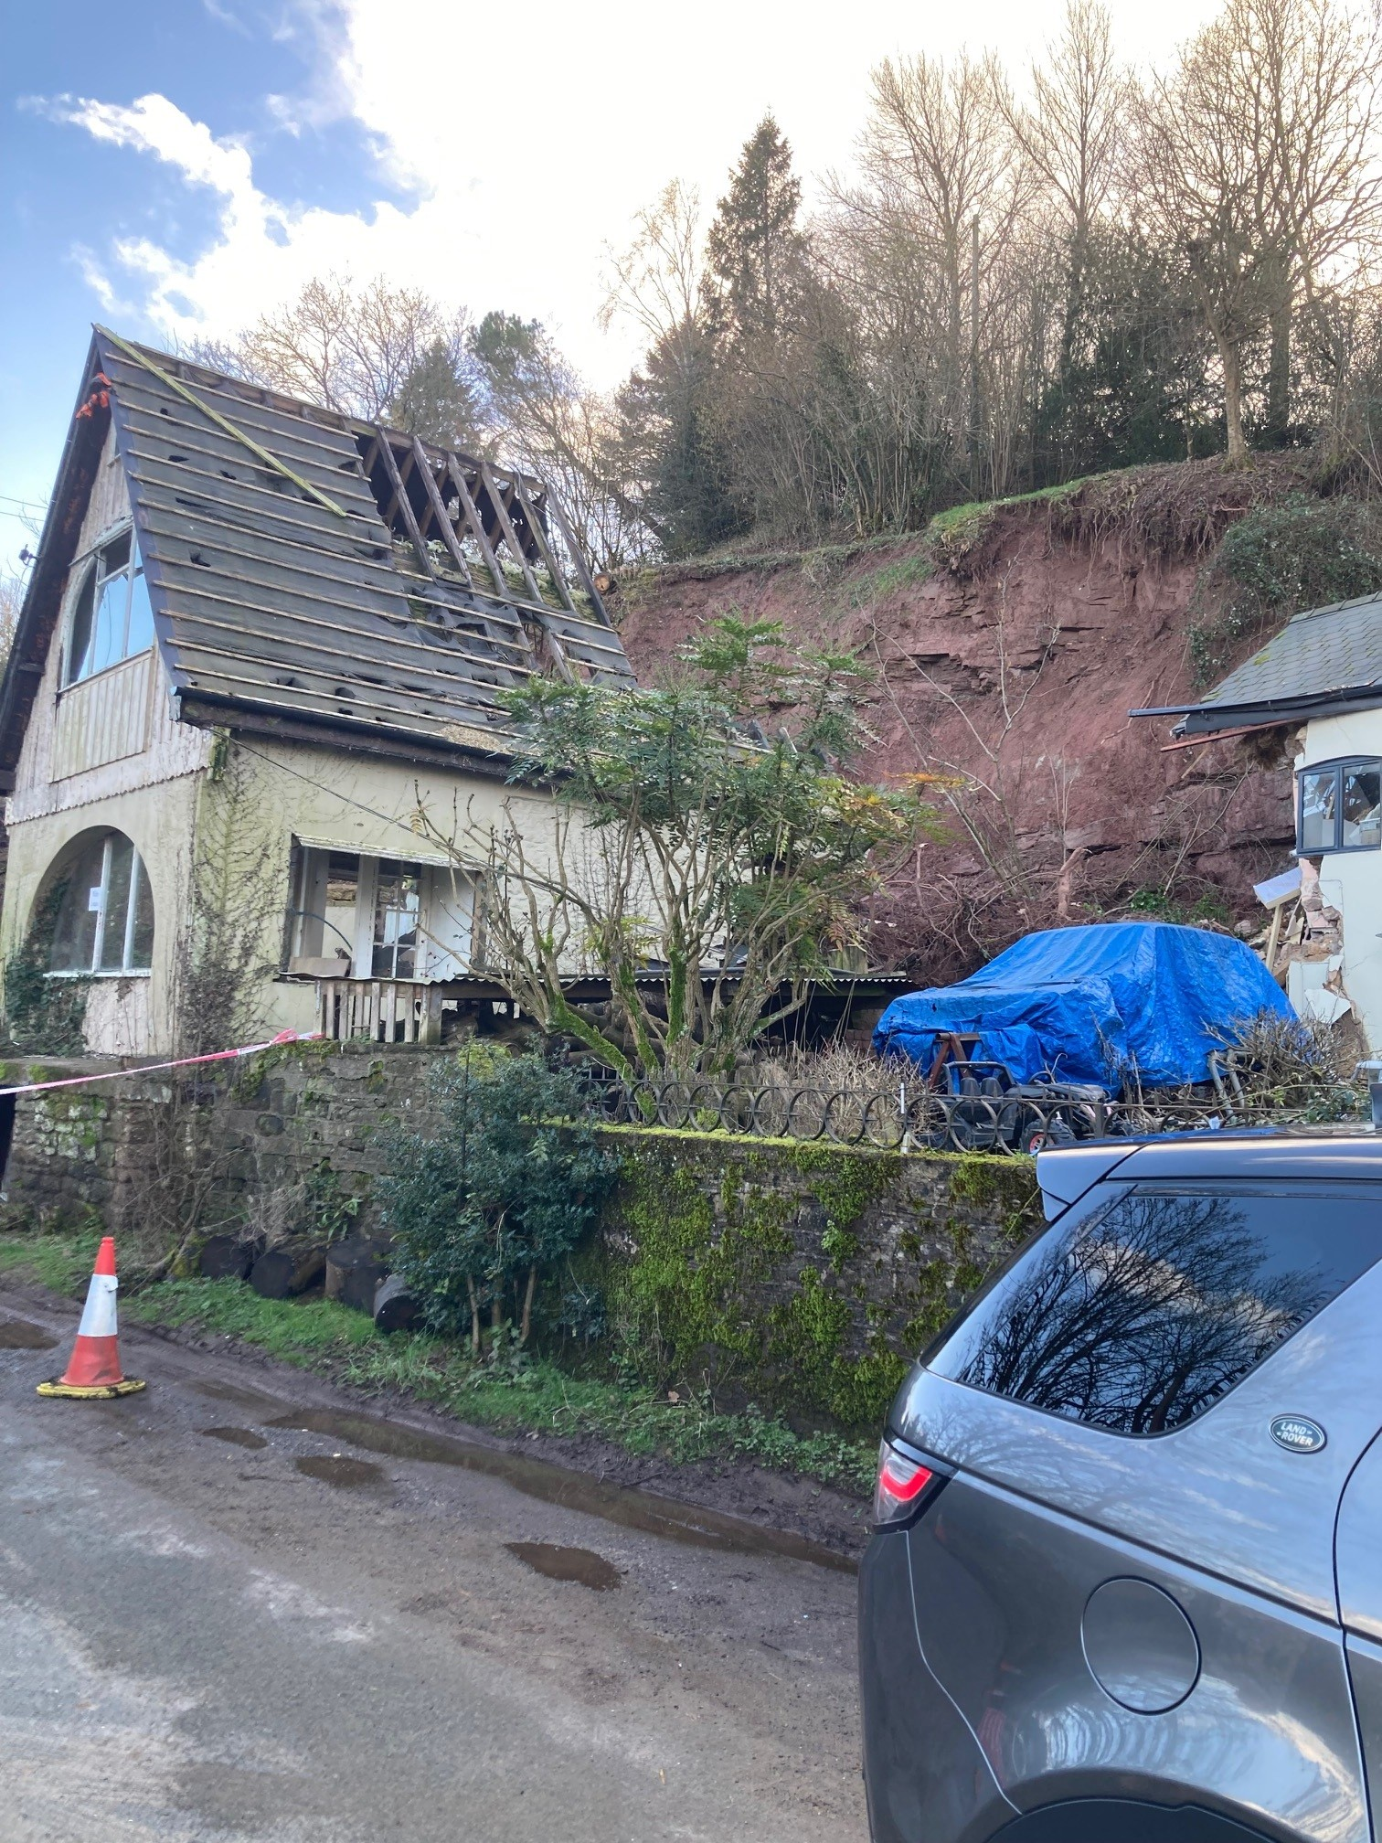
The landslip in Hoarwithy is causing concerns for all residents in the area. This has caused an increase in traffic in some areas that normally are far quieter.
Please do not try to move the barriers blocking the road, they are there for your safety. There are cameras there!
The homeowner has been contacted by the council and we are awaiting his response.
I will post updates when I have them.

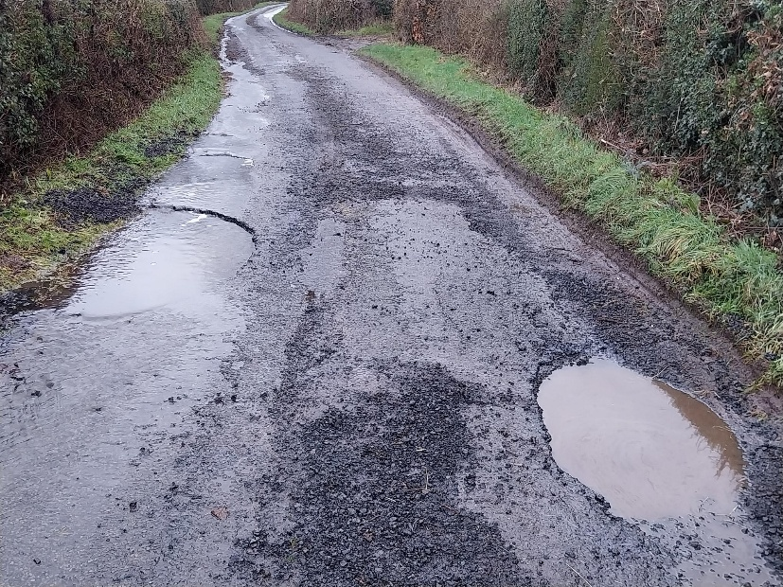
PLEASE report potholes and concerns Al
Report problems on the road –
www.herefordshire.gov.uk/roads-1/report-problems-road

Check on progress of a defect
number:herefordshire.gov.uk/roads-1/pothole-road-defect-progress-map
Report a serious pothole, flooded road or highway obstruction- Balfour Beatty Living Places : 01432 261800
Making a claim for vehicle damage : www.herefordshire.gov.uk/roads-1/highway-claims
Footpaths issues –
• PROW - PROW@herefordshire.gov.uk
• PROW No – 01432 383 550

Report fly tipping it will be dealt with in a much quicker time frame. by either calling the Contact Centre on 01432 261800 or by logging the fly tipping via the council website on the links below as your www.herefordshire.gov.uk/info/fly_tipping

Road Closures

Dinedor C1261 FROM UPPER BOWL COTTAGE TO REDBROOK
OPENREACH Utility asset works
Road closure Submitted 26-Jun '26 02-Jul '26

Green Crize U72015 LOWER BULLINGHAM LANE
OPENREACH Utility asset works
Road closure Submitted 01-Jun '26 05-Jun '26

Green Crize C1261 THE PASTURES TO GATEHOUSE ROAD
OPENREACH Utility asset works
Road closure Submitted 01-Jun '26 05-Jun '26

Hoarwithy C1261 FROM C1234 TO KNAPP GREEN
HEREFORDSHIRE COUNCIL Highway improvement works
Road closure Granted 20-Feb '26 30-Apr '26

Hoarwithy C1267 FROM HOARWITHY TO HAYNES FARM
OPENREACH Utility repair and maintenance works Road closure Granted 08-Apr '26 08-Apr '26

Holme Lacy C1266 FROM B4339 TO SNOWDELL COTTAGE
HEREFORDSHIRE COUNCIL Highway repair and maintenance works
Road closure Granted 22-Apr '26 24-Apr '26
Lower Bullingham U72015 LOWER BULLINGHAM LANE
OPENREACH Utility asset works
Road closure Submitted 01-Jun '26 05-Jun '26

Ridgehill U71616 TWYFORD COMMON ROAD FROM THE OAKS TO CHAPEL HOUSE
OPENREACH Utility asset works
Road closure Submitted 18-Jun '26 25-Jun '26

Ridgehill C1261 GATEHOUSE ROAD TO REDBROOK
OPENREACH Utility asset works
Road closure Submitted 26-Jun '26 02-Jul '26

Ridgehill C1261 GATEHOUSE ROAD TO REDBROOK OPENREACH Utility asset works
Road closure Submitted 01-Jun '26 05-Jun '26

………………………….

Parish Contacts

Ballingham, Bolstone & Hentland PC clerk@ballinghambolstonehentland-pc.gov.uk

Dinedor PC clerk@dinedorparishcouncil.gov.uk

Holme Lacy PC holmelacyparishclerk@gmail.com

Little Dewchurch PC parish.clerk@littledewchurch.org.uk

Lower Bullingham PC clerk@lowerbullinghamparishcouncil.co.uk

If you want to discuss a planning matter, please contact
planningenquiries@herefordshire.gov.uk

Planning enforcement concern
PlanningEnforcement@herefordshire.gov.uk

Local Emergency Numbers

Environment Agency: 0800 80 70 60 (24-hours) or visit www.gov.uk/report-an-environmental-incident
Flood alerts: Floodline 0345 988 1188. Sign up online at www.gov.uk/sign-up-for-flood-warnings to get Flood Warnings from the Environment Agency by phone, email or text message. If you live by a river or stream, keep a watch on current and expected water levels.

Power cut: Call 105 or visit www.powercut105.com
BT phone line issues: www.downdetector.co.uk/status/bt-british-telecom
Gas leak: 0800 111 999 or visit www.wwutilities.co.uk/services/smell-gas

Welsh Water: 0800 052 0130 (Water emergencies) or 0800 085 3968 (Sewer emergencies) or visit www.contact.dwrcymru.com/

The Citizens Advice Bureau Online at advice@citizensadviceherefordshire.org.uk for initial contact by email. Please also give a contact phone number in case we need to contact you for
more information.

