MARCH UPDATE

BALLSTONE, BALLINGHAM & HENTLAND, DINEDOR, HOLME LACY, LITTLE DEWCHURCH and LOWER BULLINGHAM
DINEDOR HILL WARD
From your local County Councillor
David Davies
david.davies2@herefordshire.gov.uk
Dear Residents

It`s been one of the wettest periods any of us can remember, the roads have really suffered with potholes and break ups all over the network. I am told that since beginning of January over 3,000 potholes have been filled with Bafour having six teams each filling over 30 potholes per day. While I have had some repairs in the ward done. I am frustrated as to amount of time its taking and numbers filled. For example, I was pleased to see the high profile potholes at Holme Lacy Road being repaired where 100m up the road the ones on the Hoarwithy mini roundabout remain untouched. Please keep reporting as highlighted in my highways section below.
The Government recently issued a revaluation of business rates to all our local businesses and some of our small businesses have seen significant increases of 50% and more. Our MP Jesse Norman has already highlighted this issue in Parliament. Together with rises in National Insurance, National Minium Wage and electricity etc this revaluation puts our valued community businesses under enormous pressure. If there are any other similar businesses impacted in the ward please contact me so we can build up our evidence base.

The Leominster Business Hub was formally launched on 2nd February at an event attended by the Leader of Herefordshire Council, Councillor Jonathan Lester, (second on left) and representatives from the local business community.
The hub offers local businesses the opportunity to speak directly with a Growth Hub Officer, access guidance on grants and finance, and use practical facilities including meeting rooms, co-working space, hot-desking and high-speed Wi-Fi, at either low or no cost.
The Business Hub is part of Herefordshire Council’s wider approach to supporting local economic growth and helps connect local businesses directly to the wider Herefordshire Growth Hub network, providing access to specialist guidance and support. Next month I have invited the recently appointed Director of Economy and environment to visit my ward and meet local medium sized businesses.
HOARWITHY LANDSLIP
On the evening of Friday the 20th of February there was another landslide in Hoarwithy striking the back of a partially demolished property and the property next door causing significant damage to the end of the property. Fortunately, no one was injured.
. 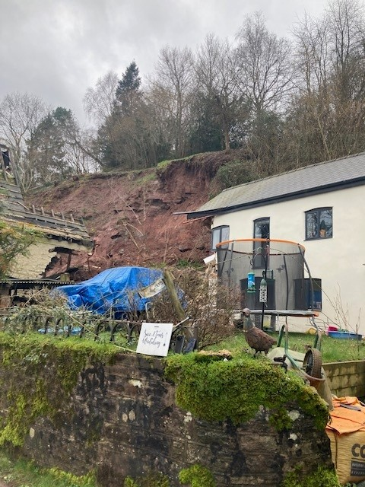
The key points are:
- Highways teams attended the scene of the landslip on Friday evening and closed the road.
- The road has been closed at this location to ensure safety of passing public.
- The landslip occurred on private land; the landowner is aware and is responsible for taking action to address the situation.
- The Council’s Building Control team and a geotechnical engineer have inspected the affected properties and site.
I have been out and met with the damaged property homeowners with me was the Cabinet member for Highways Cllr Barry Durkin.
The road closure is in place as Withy Cottage is deemed to be potentially unstable or liable to become unstable if it is struck by further landslip material. That is the current position until the inspection information is passed down. At this point I am awaiting further information from Council Officers, and I have been posting updates on social media in relation to this incident.
I will keep PC clerks informed when I get more details as well as posting on FB Village Groups.
As ever if I can be of any help, please don’t hesitate to contact me.

Stay safe and well

Dave

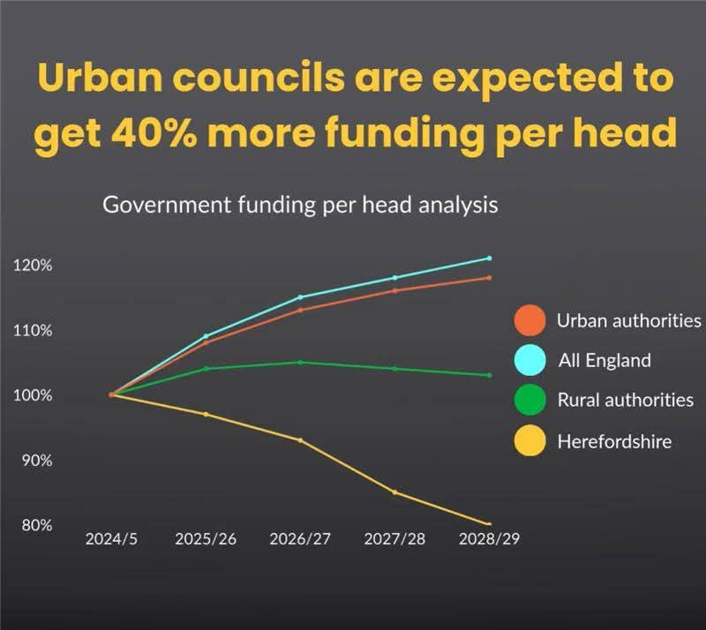
A Challenging Budget setting for Herefordshire Council
Herefordshire Council voted through the 2026/27 revenue budget at its meeting on the 13th February. There were no opposition amendments to the proposed budget with all councillors recognising it was the best that could be delivered given the Government`s reduction of financial support to Herefordshire.
The revenue budget sets out a responsible plan to close a £30 million funding gap next year, due to the outcome of the Government`s “Fair Funding Review “ not meeting the costs of the growing and more complex needs of our communities, and rural setting. This new formula equates to Herefordshire residents getting 32% less funding per head from Whitehall than those in urban areas. To balance the budget, the council identified £20 million in savings and approved a 4.99% council tax increase to meet the costs of delivering services to residents. Financial support for council tax bills will be provided to 6,500 households in the county. It leaves a challenging budget to find 20 million pounds of savings in year
I make no apologies for including again the graph opposite which shows the poor settlement Herefordshire has received for the next three years.
Residents will be aware both our neighbouring authorities Worcestershire and Shropshire are in worse financial positions. Worcestershire voted through a 9% council tax rise and is borrowing 100 million pounds from the government at 6% interest- taken out of their revenue account.
Our budget next year’s reflects what residents told the council during the Budget and Council Tax 2026/27 consultation, with highways being their top priority. In response, the capital programme includes one of the council’s largest ever investments in the roads network, including a £5 million resurfacing program and hopefully more than £24 million in Department for Transport maintenance grants to cut reactive repairs, reduce backlogs and improve road conditions countywide.
The meeting also agreed the capital (long-term spending) programme which invests in the county’s assets and infrastructure – from roads resurfacing, highways maintenance and housing. Emergency and temporary accommodation received the largest addition to the capital programme in 26/27, meaning, in the future, less reliance on private landlords and reducing the costs to the revenue budget. There will also be investment in the restoration of the county’s historic buildings and continued support for the Hereford Bypass.
Continued investment in natural environment protection, delivering two more wetlands schemes to support biodiversity recovery and nutrient neutrality. Expanded drainage, attenuation and flood alleviation works, Public Rights of Way and bridge repairs and Ash Dieback management.
Winter NHS Pressures
NHS 111 is available 24 hours a day, 365 days a year online at 111.nhs.uk or by calling 111 for any urgent but not life-threatening medical needs. Trained advisers can direct people to the best possible care for their needs, including arranging an out-of-hours GP appointment or an appointment time to attend A&E
For real emergency situations Dial 999
Our Local Community Police Team
Sign up to police alerts, you can choose which areas you want to hear about and what activity is taking place in that area. You'll also hear about positive police action, good news stories and be able to play an active part in helping us with our public appeals.
https://link.edgepilot.com/s/bb21d405/UARq0VNajkqv1vLf0zKSJQ?u=http://www.neighbourhoodmatters.co.uk/
Team contact details
Team email: herefordsouthside.snt@westmercia.police.uk
Safer Neighbourhood Officer: PC 21260 Martin Gillett Mobile: 07970 544262
Safer Neighbourhood Officer: PC 21946 Jack Davies Mobile: 07817 158224
Safer Neighbourhood Officer: PC 2347 Lyn Johnson Mobile: 07773 048377
Safer Neighbourhood Officer: PC 22088 Dan Ovel Mobile: 07929 721340
Safer Neighbourhood Officer: PC 21198 Brian Gosson Mobile: 07973 846336
Police Community Support Officer: PCSO 6324 Carol Marsh Mobile: 07890 524667
Police Community Support Officer: PCSO 40259 Hayley Warne Mobile: 07773 052560
Police Community Support Officer: PCSO 40272 Lewis Thomas Mobile: 07773 051508
We are happy to receive calls from Members of The Public, however, please do not use these to report crimes and/or incidents. For more information on reporting a crime/incident please go to www.westmercia.police.uk and select ‘Report’ or call 999 (Emergency) / 101 (Non-Emergency)

Report a crime Police 101 Ext 61216

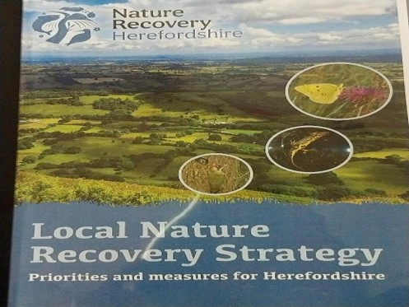
Consultation on Herefordshire Nature Recovery Strategy
Local residents, environmental groups, landowners, farmers and charities have come together with Herefordshire Council to launch a new collaborative approach to protecting and restoring Herefordshire’s natural environment
Together they have shaped the county’s first ever Local Nature Recovery Strategy (LNRS), a major new plan with 15 habitat priorities designed to protect, enhance and reconnect the landscapes, habitats and species that make Herefordshire special.
Backed by extensive mapping, expert scientific input and collaboration with landowners, charities, national agencies and community organisations over the past two years, the LNRS sets out almost 100 potential opportunities to boost biodiversity and restore natural assets across Herefordshire’s 200,000 hectares. Council specialists and partners are already working with many landowners on local projects.
A public consultation has now been launched to get wider feedback and input into the plan – including potential for even more opportunities to enhance the environment for the future. An interactive online map allows people to zoom in on 42 potential habitat measures and 12 supporting actions, plus 43 potential species measures.
The LNRS is not a list of mandatory schemes. Instead, it outlines a menu of voluntary ideas and suggestions, alongside existing nature reserves, wildlife sites and unique habitats, that residents, farmers and all types of landowners can choose to pursue with support from the Council and partners. Council staff are already working with landowners, environmental charities and others in the county wide effort to create healthier habitats, cleaner watercourses, richer wildlife and more resilient ecosystems.
Consultation closes on 22nd March : https://www.herefordshire.gov.uk/news/2026/february/local-nature-recovery-strategy-consultation/

HIGHWAYS
The winter season is having its impact on our highways and I do urge you to report concerns

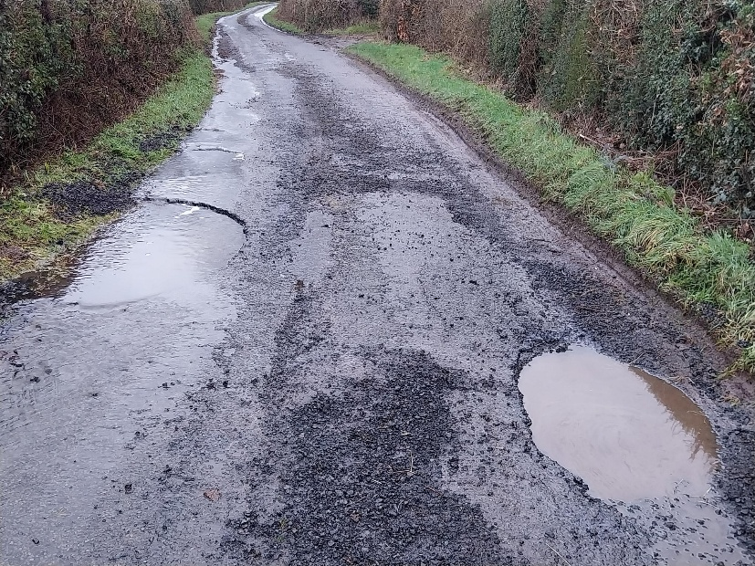
PLEASE report potholes and concerns Al
Report problems on the road –
www.herefordshire.gov.uk/roads-1/report-problems-road

Check on progress of a defect
number:herefordshire.gov.uk/roads-1/pothole-road-defect-progress-map
Report a serious pothole, flooded road or highway obstruction- Balfour Beatty Living Places : 01432 261800
Making a claim for vehicle damage : www.herefordshire.gov.uk/roads-1/highway-claims
Footpaths issues –
• PROW - PROW@herefordshire.gov.uk
• PROW No – 01432 383 550

Report fly tipping it will be dealt with in a much quicker time frame. by either calling the Contact Centre on 01432 261800 or by logging the fly tipping via the council website on the links below as your www.herefordshire.gov.uk/info/fly_tipping

Road Closures

Dinedor U72009 HOLLOW FARM ROAD
OPENREACH Utility asset works
Road closure BC008WFQT1W8YSB-02
Submitted 14-May '26 14-May '26

Hentland C1234 FROM A49 TO SHEPPON HILL STABLES HOARWITHY
OPENREACH Utility asset works
Road closure BC008WG8G8N9ZSB-02
Granted 31-Mar '26 31-Mar '26

Hoarwithy C1261 FROM C1234 TO KNAPP GREEN
HEREFORDSHIRE COUNCIL Highway improvement works
Road closure FL01041743498-01
Granted 20-Feb '26 27-Feb '26

Hoarwithy C1267 FROM HOARWITHY TO HAYNES FARM
OPENREACH Utility repair and maintenance works
Road closure BC518MAPLWWG5P739M-05
Granted 08-Apr '26 08-Apr '26

Holme Lacy C1266 FROM B4339 TO SNOWDELL COTTAGE
HEREFORDSHIRE COUNCIL Highway repair and maintenance works
Road closure FL23080906971-01
Submitted 22-Apr '26 24-Apr '26

Little Dewchurch U72002 KNAPP GREEN
OPENREACH Utility asset works
Road closure BC008WG1FWH8LSB-03
Granted 11-Mar '26 11-Mar '26

Rotherwas B4399 FROM GATEHOUSE ROAD TO ROTHERWOOD
HEREFORDSHIRE COUNCIL Remedial works
Two-way signals FL01082393825-01
Granted 25-Feb '26 25-Feb '26

………………………….

Parish Contacts

Ballingham, Bolstone & Hentland PC clerk@ballinghambolstonehentland-pc.gov.uk

Dinedor PC clerk@dinedorparishcouncil.gov.uk

Holme Lacy PC holmelacyparishclerk@gmail.com

Little Dewchurch PC parish.clerk@littledewchurch.org.uk

Lower Bullingham PC clerk@lowerbullinghamparishcouncil.co.uk

If you want to discuss a planning matter, please contact
planningenquiries@herefordshire.gov.uk

Planning enforcement concern
PlanningEnforcement@herefordshire.gov.uk

Local Emergency Numbers

Environment Agency: 0800 80 70 60 (24-hours) or visit www.gov.uk/report-an-environmental-incident
Flood alerts: Floodline 0345 988 1188. Sign up online at www.gov.uk/sign-up-for-flood-warnings to get Flood Warnings from the Environment Agency by phone, email or text message. If you live by a river or stream, keep a watch on current and expected water levels.

Power cut: Call 105 or visit www.powercut105.com
BT phone line issues: www.downdetector.co.uk/status/bt-british-telecom
Gas leak: 0800 111 999 or visit www.wwutilities.co.uk/services/smell-gas

Welsh Water: 0800 052 0130 (Water emergencies) or 0800 085 3968 (Sewer emergencies) or visit www.contact.dwrcymru.com/

The Citizens Advice Bureau Online at advice@citizensadviceherefordshire.org.uk for initial contact by email. Please also give a contact phone number in case we need to contact you for
more information.

